Software Requirements Specification

For

Raiment Collection

Ecommerce Store

Prepared by: Muhammad Wasim – 9323

Version 2

Nov 26th, 2020

Table of Contents

Table of Contents ii

Revision History ii

1. Introduction 1

1.1 Purpose 1

1.2 Document Conventions 1

1.3 Intended Audience and Reading Suggestions 1

1.4 Project Scope 2

1.5 References 2

• "SRS for Dynamic Commerce Catalyst”. Retrieved 8 Dec 2014. 2

2. Overall Description 3

2.1 Product Perspective 3

2.2 Product Features 4

2.3 User Classes and Characteristics 4

2.4 Operating Environment 5

2.5 Design and Implementation Constraints 5

2.6 User Documentation 5

2.7 Assumptions and Dependencies 6

3. System Features 7

3.1 Content Management System 7

3.2 Sub Admins 8

3.3 Customer Registration 8

3.4 Product Modification 9

3.5 Order Management 9

3.6 Add to Cart and Check Out 10

3.7 Integrated Centralized Database 10

4. External Interface Requirements 12

4.1 User Interfaces 12

4.2 Hardware Interfaces 16

4.3 Software Interfaces 16

4.4 Communications Interfaces 17

5. Other Requirements 18

5.1 Operating Systems 18

5.2 Programming Language 18

5.3 Software Reuse 18

5.4 Internationalization Requirements: 18

Appendix A: Glossary 19

Same as 1.2 document convention. 19

Appendix B: Analysis Models (UML Diagrams) 19

Kindly find out these requirement on the document of UML Diagrams. 19

Revision History

|  |  |  |  |
| --- | --- | --- | --- |
| **Name** | **Date** | **Reason For Changes** | **Version** |
|  |  |  |  |
|  |  |  |  |

# Introduction

## Purpose

In today’s modern world, nobody has time to go shopping outside even if we talk about clothing. **Raiment Collection** is a web based application which is reachable and usable for every type of users who owns their business. The main purpose of this project to provide 24 hours online shopping facility of Pakistani clothing to every kind of people even if they are in abroad. They get their favourite Pakistani clothes at their home within 7 days. Also our focus to make a user friendly website so If any user who can use cell phones and computer can easily use the system.

Also in a pandemic situation, when the physical market has been crashed and shut down in many countries in the world and everybody wants to ensure social distancing, this project really helps them and facilitates them to shop clothes online from home.

## Document Conventions

Main Heading Font – Arial, Bold, 18

Sub Heading Font – Calibri, Bold, 14

Body Content Font – Calibri, 12

CMS – Content Management System

PP – Project Plan

PAF KIET – Pakistan Air Force – Karachi Institute of Economic and Technology

SRS – Software Requirement Specification

GUI – Graphical User Interface

ERD – Entity Relationship Diagrams

UML – Unified Modelling Language

DFD – Data Flow Diagram

OOAD – Object Oriented Analysis and Design

SDLC – Software Development Life Cycle

## Intended Audience and Reading Suggestions

This document is intended for developers who will developed the system after reading this SRS, project managers who will manage all kinds of operation regarding developing, time and cost and users who will use this system overall in future. This document contains the Software Requirements Specifications for this project. It covers the features of this application, the use cases, the technical background and user interface specifications.

Suggested sequence for reading SRS is:

1. Overall Description
2. System Features
3. External Interface Requirements
4. Non Functional Requirements

## Project Scope

The scope of ecommerce industry in the world is developing day by day. Internet in today’s world is the main resource of each and every activity that takes place, shifting business online is the not only the most profitable step that is taken by every business man today but it also binds a repute with that particular business, a fame and quality that is known to every person that visits that site. As we know that the world is getting digital and people have not so much time to go to the market and buy something because that may take some time so the ecommerce is the only option that they have. Ecommerce stores are increasing frequently, in every aspect of internet life and especially in business marketing plays vital role in production for that purpose you need online business via net or via mobile etc. They just need to open the smartphone or laptop/desktop and search for the product they want and the product will be shipped to them in the given time. So the scope of this project is very high.

Our scope is to provide effective and easiest ecommerce business solutions. The best thing about this project is that it is so market friendly so any domain like clothing, electronic and many more accessories brand can use this project without any difficulties. Also this application is beneficial for both large and small business peoples because this is not restricted that if a person has large capital for his business so only he will do marketing through web. Due to globalist application it is reachable for every type of person so if he is doing small business so he can also maintain his website and that will affect the production definitely. So we can say that scope of this project is very vast in the industry who want to come in ecommerce domain to sell their product and item without any hurdles.

## References

## "SRS for Dynamic Commerce Catalyst”. Retrieved 8 Dec 2014.

* "SRS Template”. Retrieved 14 Sep 2020.

# Overall Description

## Product Perspective

Raiment collection is a web based application, which is very effective for business manager and the general user. Admin team will be involved in this project so that they can manage the application. The application will be accessible through web browsers to all over the world. This application will have 2 modules, an admin area where admin can login and manage all data and a dynamic ecommerce portal where any kind of user can register or login and shop online. Both modules are connected with database to maintain all records.

**Internal Interfaces:**

Database:

* Creates reports
* Stores data
* Provides access to data
* Updates information

Web Server:

* Provides access to the database
* Authenticates users
* Processes information
* Performs backups

**External Interfaces:**

Personal Computers:

* Users: Admins and general users.

Cell Phones:

* Responsive application so can be used in cell phones.

**Computer Hardware and Peripheral Equipment to be used**:

* Personal Computers (i.e. CPUs, monitors, keyboards, and mice).
* Network
* Cell phones

## Product Features

* Main Admin can login and monitor all activities.
* Admin can make sub-admins to help him to manage the application
* Admin or sub-admin can insert and update the data.
* Only admin can delete the data, sub-admins won’t have rights to do.
* Admin or sub-admin also can register customer as well.
* Admin or sub-admin can see and change the status of any order.
* User can register himself/herself via signup page.
* User is allow to add to cart functionality only if he/she is login.
* User can check out any time from cart page or add/delete product from cart as well.

## User Classes and Characteristics

1. **Admin Staff**

* Data Entry Operator
* Designer
* Marketing Team
* Sales Team
* Manager who can manage all above department

Admin staff should be familiar with the following:

* Working on a CMS
* Using a browser like navigating through the links
* Searching the required information
* Should know the details of a transaction

1. **General Users**
   * Clothing Wholesaler
   * Clothing Designers
   * Boutique
   * Local Tailors
   * Local Clothing Store Owners

General user should be familiar with the following:

* Working on a website
* Using a browser like navigating through the links
* Should know how to use add to cart and checkout.

For the proper user interface, user’s manual, help of system must be sufficient to educate the users on how to use the system without any problems.

## Operating Environment

Operating environment for Raiment Collection as listed below:

* Distributed Database
* Client/Server System
* Operating System: From Windows 7 onwards.
* Database: SQL Server 2017
* Platform: Visual Studio 2017, ASP.Net, MVC 5, HTML 5
* Language: C#

## Design and Implementation Constraints

* Developer should know MVC and ADO.net environment.
* Design will be responsive as google suggest.
* Database will only be developed on SQL Server.
* Developer must know about database queries.
* Database will be design as centralized and relational.
* Project will be ready before two weeks of PAF-KIET final exams.
* Customer must have license to do ecommerce business.
* Only cash on delivery will be available on site.

## User Documentation

Below the list will be deliver to customer:

* Software Requirement Specification
* Use Case Diagrams
* Class Diagrams
* Analysis Diagrams
* Prototyping Model
* User Manual

## Assumptions and Dependencies

Raiment clothing store is an old clothing store which have simple and not user friendly interface to use it. Customer can’t make their account and neither can they shop online.

Client is also very fade up with the software so he approached me to recreate and recreate the design and also developed as on online store so customer can shop online.

The old website designed on only basic html tool and Client don’t have the project for editing, so we will developed this project from the scratch on MVC 5 on visual studio 2017 and for database we will use SQL server 2017

# System Features

Raiment Collection is based on online ecommerce platform for online shopping and the best thing about that it’s easy to use platform for non-technical user. This system contains the features that makes this system easier and faster to use even a non-programmer can avail it efficiently. Everyone knows that online shopping is hot cake now a days and many business man, retailers, home chefs , designers, tailors want to expand their business via online so everyone can connect them in the world and there is not any restriction to stop them make a good revenue. This system domain is very spacious and flexible so every market users can use this in their own industry. Main features of our system are defined briefly as follows.

## Content Management System

The most significant feature will be the CMS itself. This is the heart of the system and admin or sub-admin will use it to enter the data, modify and can see the status and every things.

**3.1.1 Description and Priority**

A content management system (CMS) is a [computer system](http://en.wikipedia.org/wiki/Computer_system) that allows [publishing](http://en.wikipedia.org/wiki/Electronic_publishing), [editing](http://en.wikipedia.org/wiki/Editing), and modifying [content](http://en.wikipedia.org/wiki/Content_(media)) as well as site maintenance from a central page. It provides a collection of procedures used to manage workflow in a collaborative environment. CMS are frequently used for storing, and controlling the overall system. Admin or sub-admin can see the currently active orders as well as customers also. If any customer wants to know the status then admin can see the order status easily as well as change it also. CMS has the top priority because everything of the system will be managed here.

**3.1.2 Functional Requirements**

* The Content Management System of Raiment Collection will be providing to the owner and admins. It has the capability to change entire look and facts/information of his/her business.
* In order to access the CMS, owner and admins have their unique ID.
* CMS will also be checking the data entered by the admin and will be checking whether it’s correct or not, to ensure the quality of data.
* All the information provided by the user should be correct and accurate, in order to keep record of the sales of the business.
* Log will also be maintain to keep the record of CMS activities.

## Sub Admins

Sub-admins can be made by main or super admin to help him/her to maintain the quality of content of online store. This is the key feature in any system.

**3.2.1 Description and Priority**

Sub-admin will have all the access to insert and modify the product and customer information but they cannot delete any information from CMS. Delete access will only be available to main admin. Also he/she can check the status of order and can change it according to need. Sub admin activities will be recorded by CMS log so admin can monitor the all activities. It has the higher priority about 90% so data can be protected.

**3.2.2 Functional Requirements**

* Sub Admin will receive Id and pass via email.
* When there will be any update in system by sub-admin, main admin will get this activity via log.
* Sub Admin cannot delete anything from the system.
* System will maintain the log of sub admin activity.

## Customer Registration

Customer registration will be the very important feature. Customer can register himself/ herself in the system so he/she can order the product.

**3.3.1 Description and Priority**

Customer registration is very import part of the system. Customer record is necessary to do online shopping so that there will be no any fake orders to dispatch any fake address of fake customer. This is very necessary in Pakistan because sometimes people order something because of fun and company has to face the consequences.

Customer can register himself/ herself and also admin or sub-admin can do it. Because sometimes order will generate from WhatsApp or landline so that customer record can be maintain. After successful registration, customer will received an email about successful registration. This has the low priority, because customer will only can register when all system has been designed.

**3.3.2 Functional Requirements**

* Customer’s information will be recorded.
* Customer will receive an email after registration
* Admin or sub-admin can register the customer also.

## Product Modification

This is the main feature in system. Without this feature, website won’t display any product so customer cannot see and buy anything. Admin or sub-admin can use this feature to insert, update and delete the products.

**3.4.1 Description and Priority**

Product information is everything to the customer. What is product’s brand, what is its type? The all information will be very useful for the customer. Admin or sub-admin has the responsibility to add or update the products. Product name, description, brands, type and every possible information will be inset from respective input fields. Also in this feature, admin or sub-admin can upload the images of the product and cab mark the main picture also and that main picture will appear on the website. This feature has high priority because all shopping facility depends on this feature.

**3.4.2 Functional Requirements**

* Admin or sub-admin can insert the products.
* For images of each product also will be uploaded and can be marked main any one of them.
* Admin or sub-admin can update any product at any time.
* Admin or sub-admin can marked the products “Hot Item” and “Featured”.

## Order Management

Order management is the feature, where admin or sub-admin can track and see all the orders which have been placed by the customer.

**3.5.1 Description and Priority**

Order management is very important feature to track all the orders from the customers. It will show the list orders and by clicking on it, admin or sub-admin can see the all details of the particular order. It will show the product or items which have been ordered from customers and their respected amount and total bill. Priority is normal enough because this feature is available after all necessary steps regarding online store.

**Optional:** A receipt can be print from order detail page for manual record.

**3.5.2 Functional Requirements**

* Order will be track here.
* Complete information of order including product, quantity and amount.
* List will show the status of the order either it is pending or shipped.
* Admin or sub-admin can change the status of order.

## Add to Cart and Check Out

Customer can add to cart any product by login himself/ herself. This is very important feature and all ecommerce website use this to satisfy customer needs.

**3.6.1 Description and Priority**

Add to cart functionality is very common and useful for any ecommerce website. Customer can add any product to the cart so that he/she can order more than one item at a time. Customer has to login to use this feature so database will be maintain of cart items of particular customer. So that, when the customer will come again, the cart items will be there until he/she will delete it or check out for order placed.

Once customer add desire products to the cart, he/she can do checkout from the cart page by enter shipping address and cell number. Cart page will show the total amount for customer.

**Optional:** Once the checkout process will be done, an email will dispatch to the customer.

**3.6.2 Functional Requirements**

* Add to cart functionality available for customer.
* Only registered user can use this feature.
* After add to cart, customer can do checkout any time.
* Order bill will be generated and received by customer via email.(Optional)

## Integrated Centralized Database

An integration database will be a database which will act as the data store for multiple applications (modules), and thus will be integrating data across these applications. The benefit of this will be that sharing data between applications will not require an extra layer of integration services on the applications. Any changes to data made in a single application are made available to all applications at the time of database commit - thus keeping the applications' data use better synchronized.

**3.7.1 Description and Priority**

This feature is very helpful and effective because it will help to maintain database in single layer you don’t need to have multiple database for applications. You can maintain database such as edit, update or delete on one layer. It will be really helpful to maintain all record at one place and it will share all necessary detail to every admin or sub-admin so that they can do their work easily. Database has the top and very high priority from all feature because this is the main source to store all the information. Without database, all above mention features are nothing. Only owner of the company and developers’ team can have the access to use it.

**3.7.2 Functional Requirements**

* Customer’s information which includes personnel information and account info will be recorded.
* All Products information include images paths will be recorded.
* Sub-admin’s information will also be managed here.
* Order’s information will be managed.
* It’s a relational database so all related table can interact with each other.

# External Interface Requirements

## User Interfaces

There will be two types of user interface, one will be for Admins and Sub admins, and other for end customers. Both interfaces will be web-based application. In the interface of Admin and Sub-Admin, the look will be like a dashboard. Interface will be user friendly so admin or sub admin can easily navigate through the application. They can easily modify the customer end website and also can add or update the information regarding products. Also, they can easily track the orders which are pending from their side.

Customer end interface like an ecommerce store where he/she can see the all products of store.

Also, it will be user friendly so that he/she can go any page from current active page. Also, customer can register himself and can add to cart. Later on, they can check out any time. Even if they will logout, product remain on their cart so that they can checkout any time they want.

This web application which we called "Raiment Collection" have different page of its features which are as follows

* Manage Users
* Manage products
* Manage Customers
* Manage Orders
* Customer end portal
* Product and Product detail page.
* Cart Items

**Here’s some examples of Admin area.**

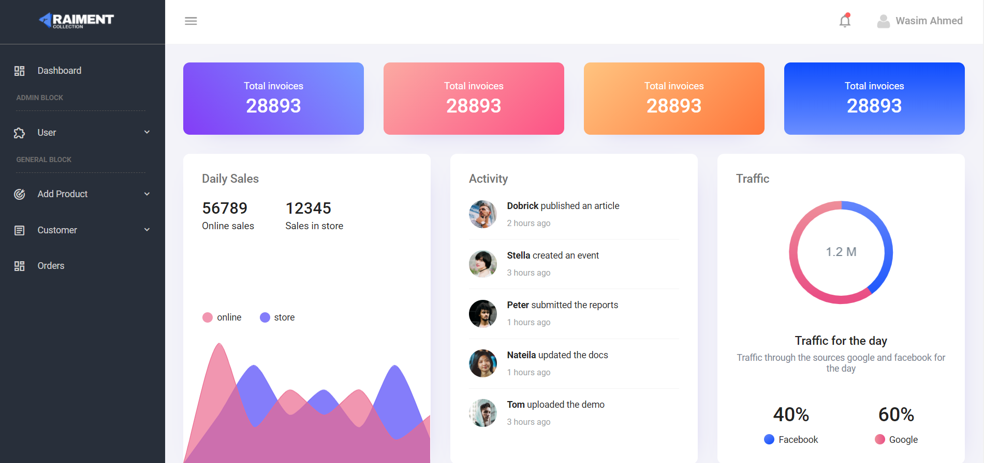

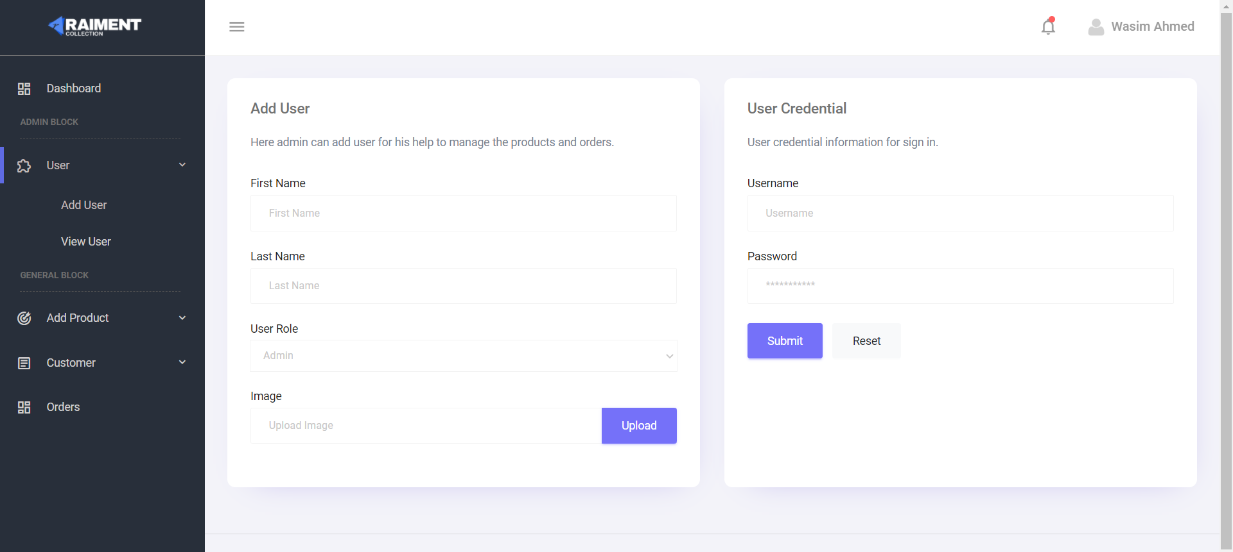

**Here’s some examples of Customer store.**



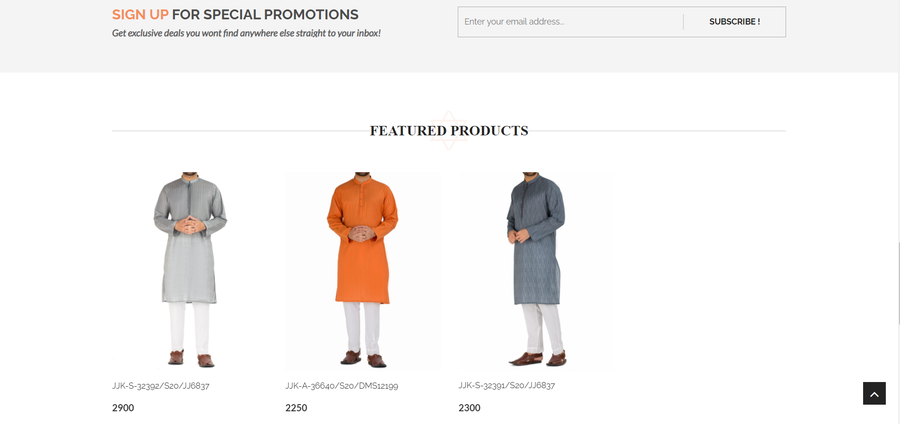

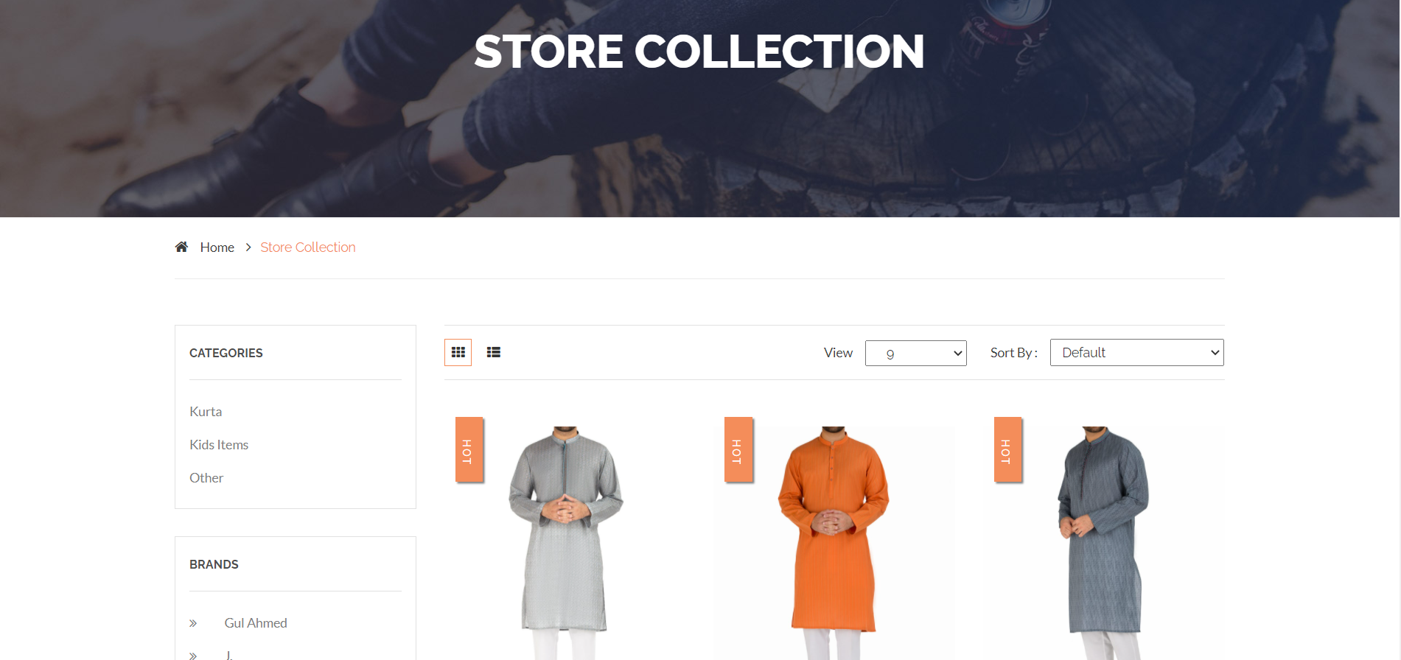

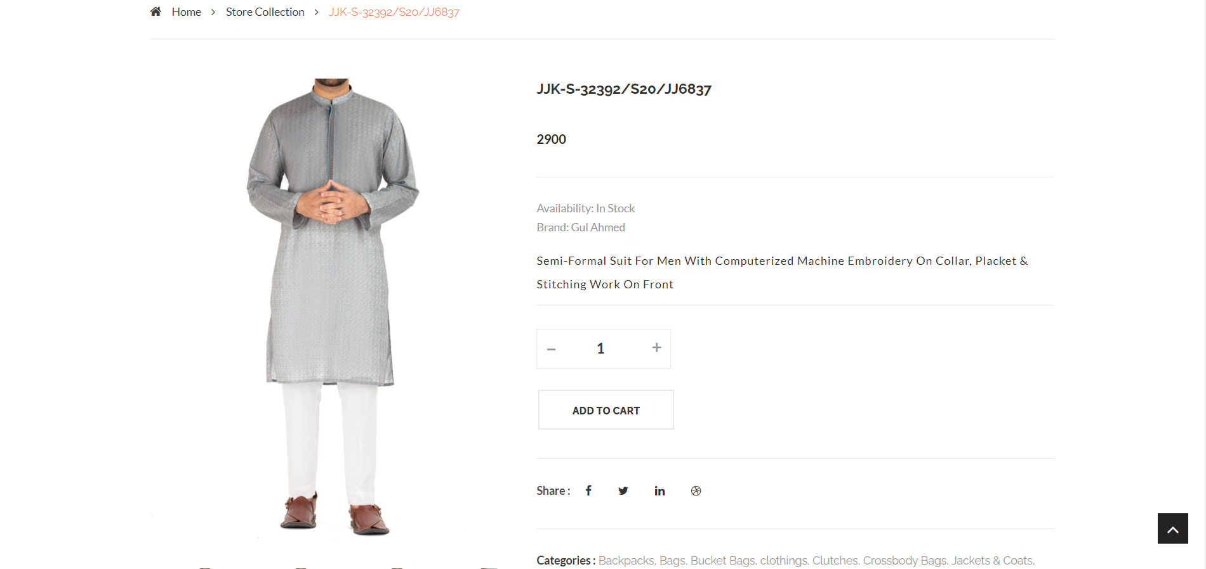

## Hardware Interfaces

Raiment collection will be compiled on PCs, which communicate with the server. The server then communicates with the database. The protocol involved between the PC's and the server is the HTTP protocol, which allows communication between the PC's and the Server. The remote PC's, such as someone accessing the IMS from home using the Internet, are able access the information through the web application. The requests come in through the HTTP protocol, and using the database results are returned and processed using ASP to give an HTML web page. The format of the output is displayed as web pages. Our required hardware interfaces to develop Raiment Collection are discussed below.

Hardware requirements are

* Intel Core Processor
* 4 GB Ram
* 10 GB Hard drive
* Internet connection (min 2MB)

## Software Interfaces

A computer language whereby computer programs can communicate with each other, and one language can call upon another for assistance. We are using software interfaces as per DCC requires.

ASP.net is a secure and Microsoft certified platform for web server package, consisting mainly of the .net HTTP Server, SQL Server database, and interpreters for scripts written in the ASP and C# programming languages.

Information about the products used for the IMS are as follows:

(1) Name: SQL Server

(2) Version Number: 2017

(3) Source: Microsoft

(1) Name: Visual Studio 2017

(2) Version Number: 2017

(3) Source: Microsoft

(1) Name: Windows10

(2) Source: Microsoft

(1) Name: Google Chrome

(2) Mnemonic: Chrome

(4) Source: Microsoft

Other Software requirements are

* Adobe Photoshop
* CSS
* HTML
* .Net Framework

## Communications Interfaces

The user communication interface is the internet because Raiment Collection Store is the web based application and user can communicate through the internet and develop their required websites without wasting extra money and time.

# 

# Other Requirements

**Design Constraints**

## Operating Systems

Raiment Collection shall, as it’ll be a web application, support the following Operating Systems:

* Microsoft Windows
* Linux
* Mac OS

## Programming Language

The Raiment Collection shall be implemented using ASP and shall work with the following compilers:

* ASP.net
* C# Compiler

## Software Reuse

Raiment Collection shall be reused to extend its features and credibility, which can be achieved by editing ASP classes.

## Internationalization Requirements:

Further in future if we wants to extend the project international trade we need to introduce it to the international trade market and make it compatible with the needs and requirements of international trade. Many new features should be added according to the requirements of those customers or stakeholders.

Appendix A: Glossary

Same as 1.2 document convention.

Appendix B: Analysis Models (UML Diagrams)

Use Case Diagrams

1. Manage Sub-Admins

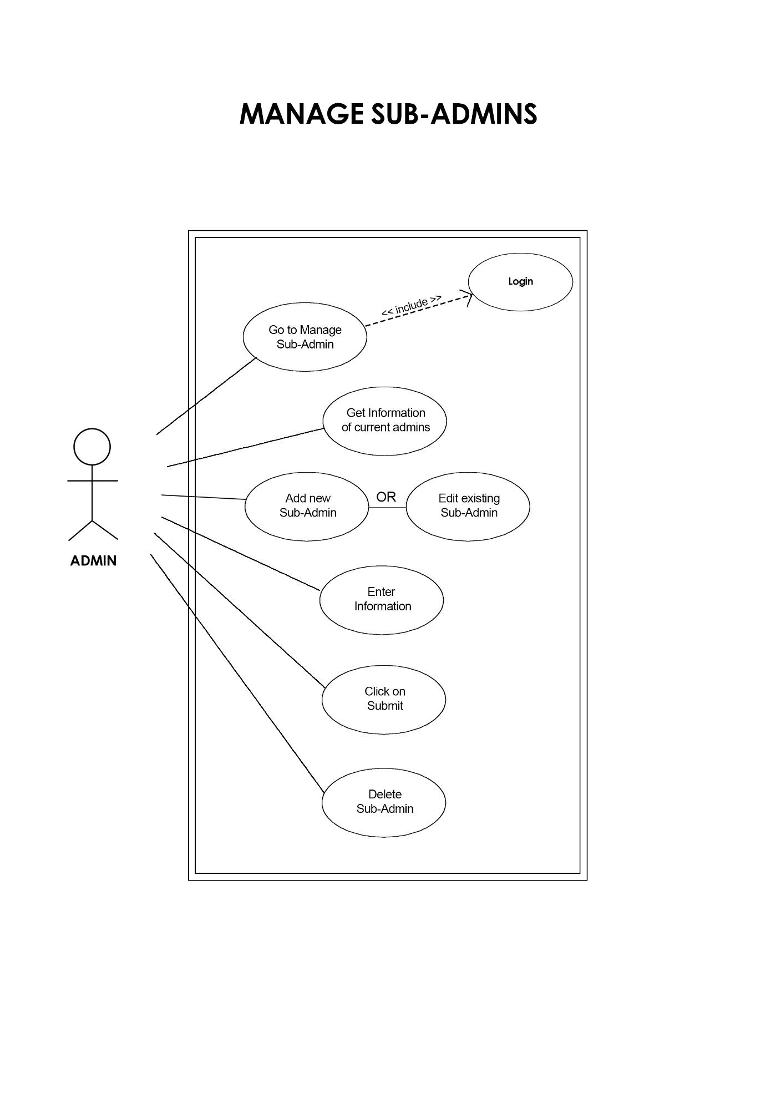

1. Customer Registration

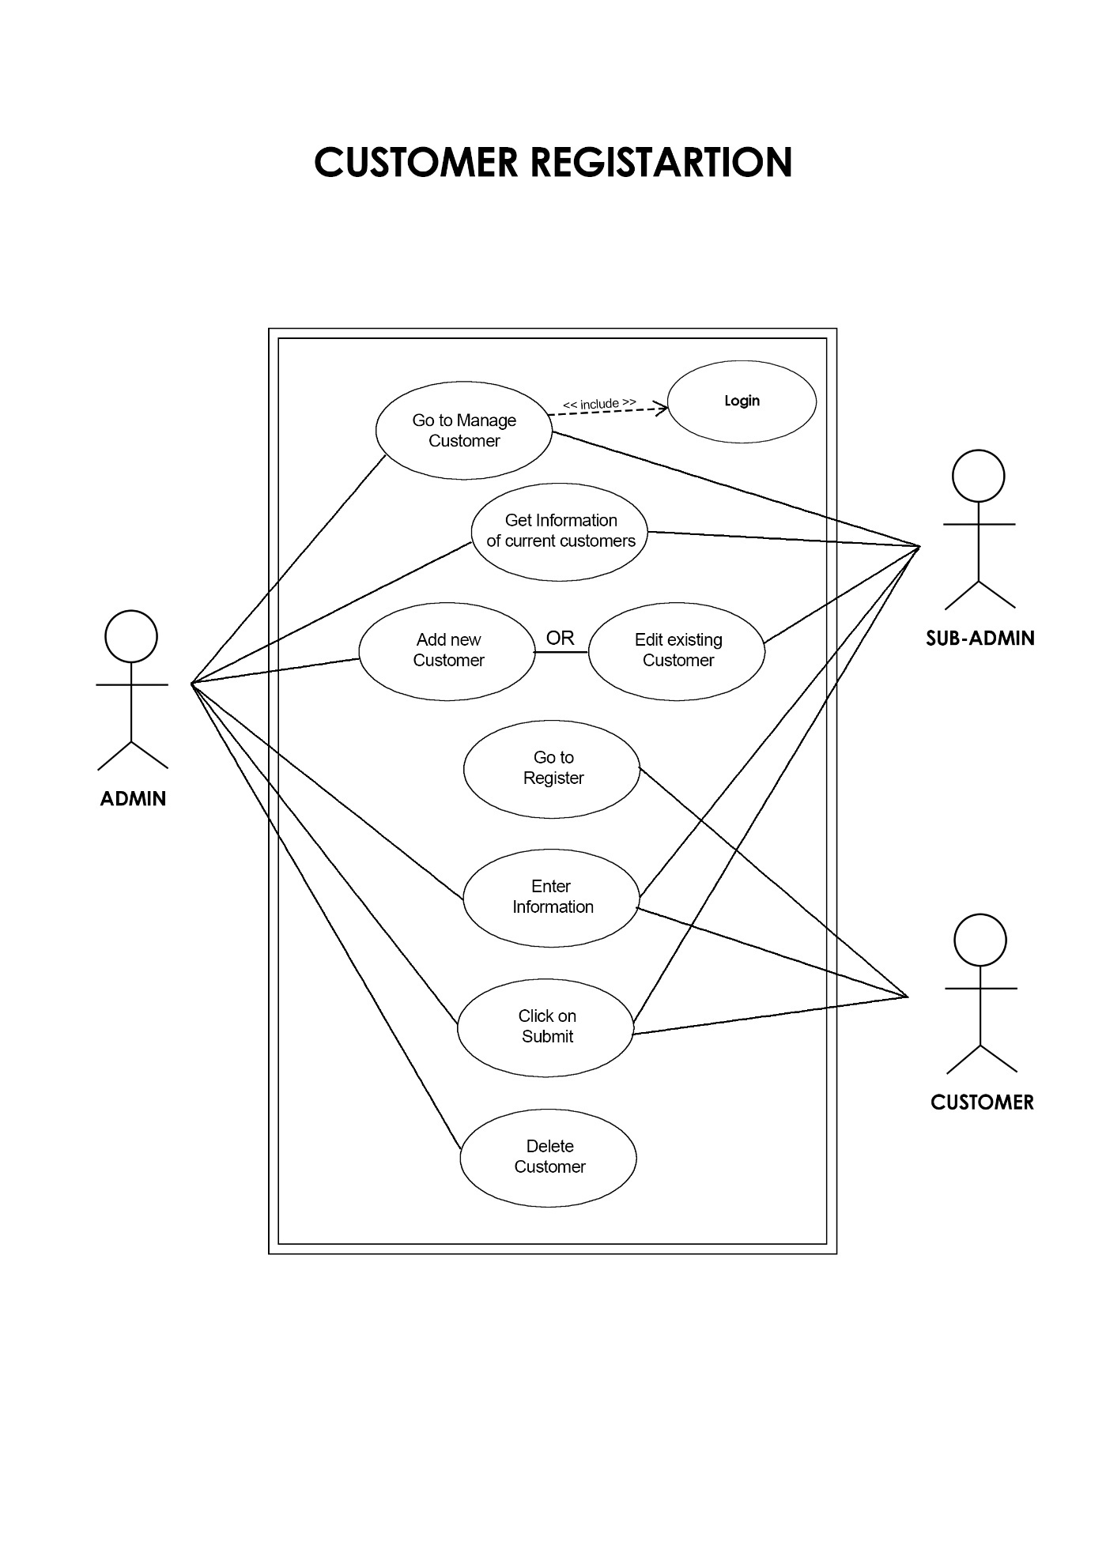

1. Product Management

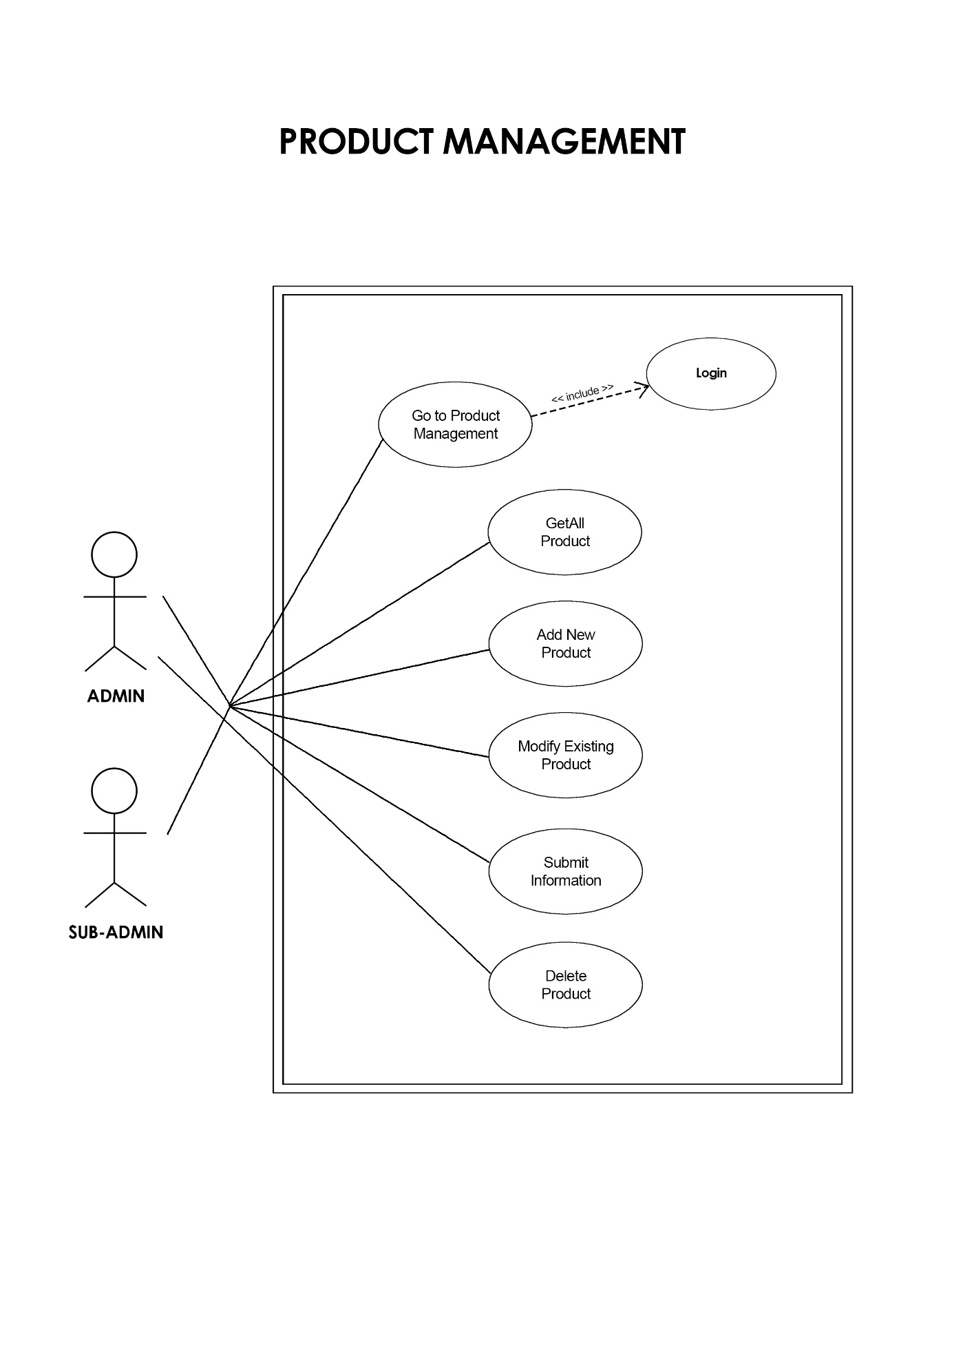

1. Order Management

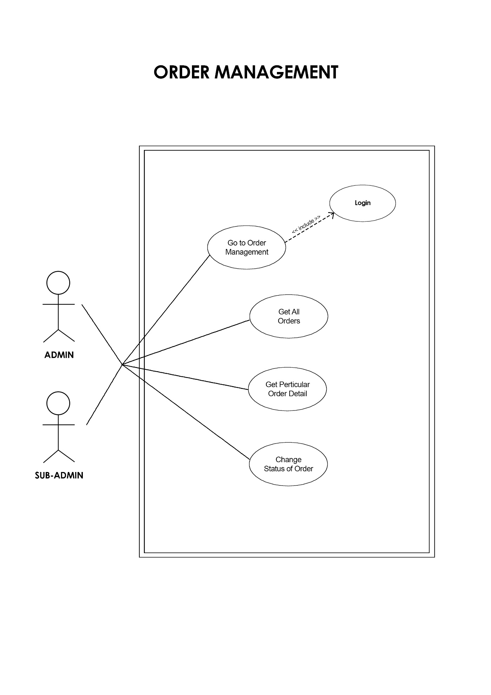

1. Add to Cart and Checkout

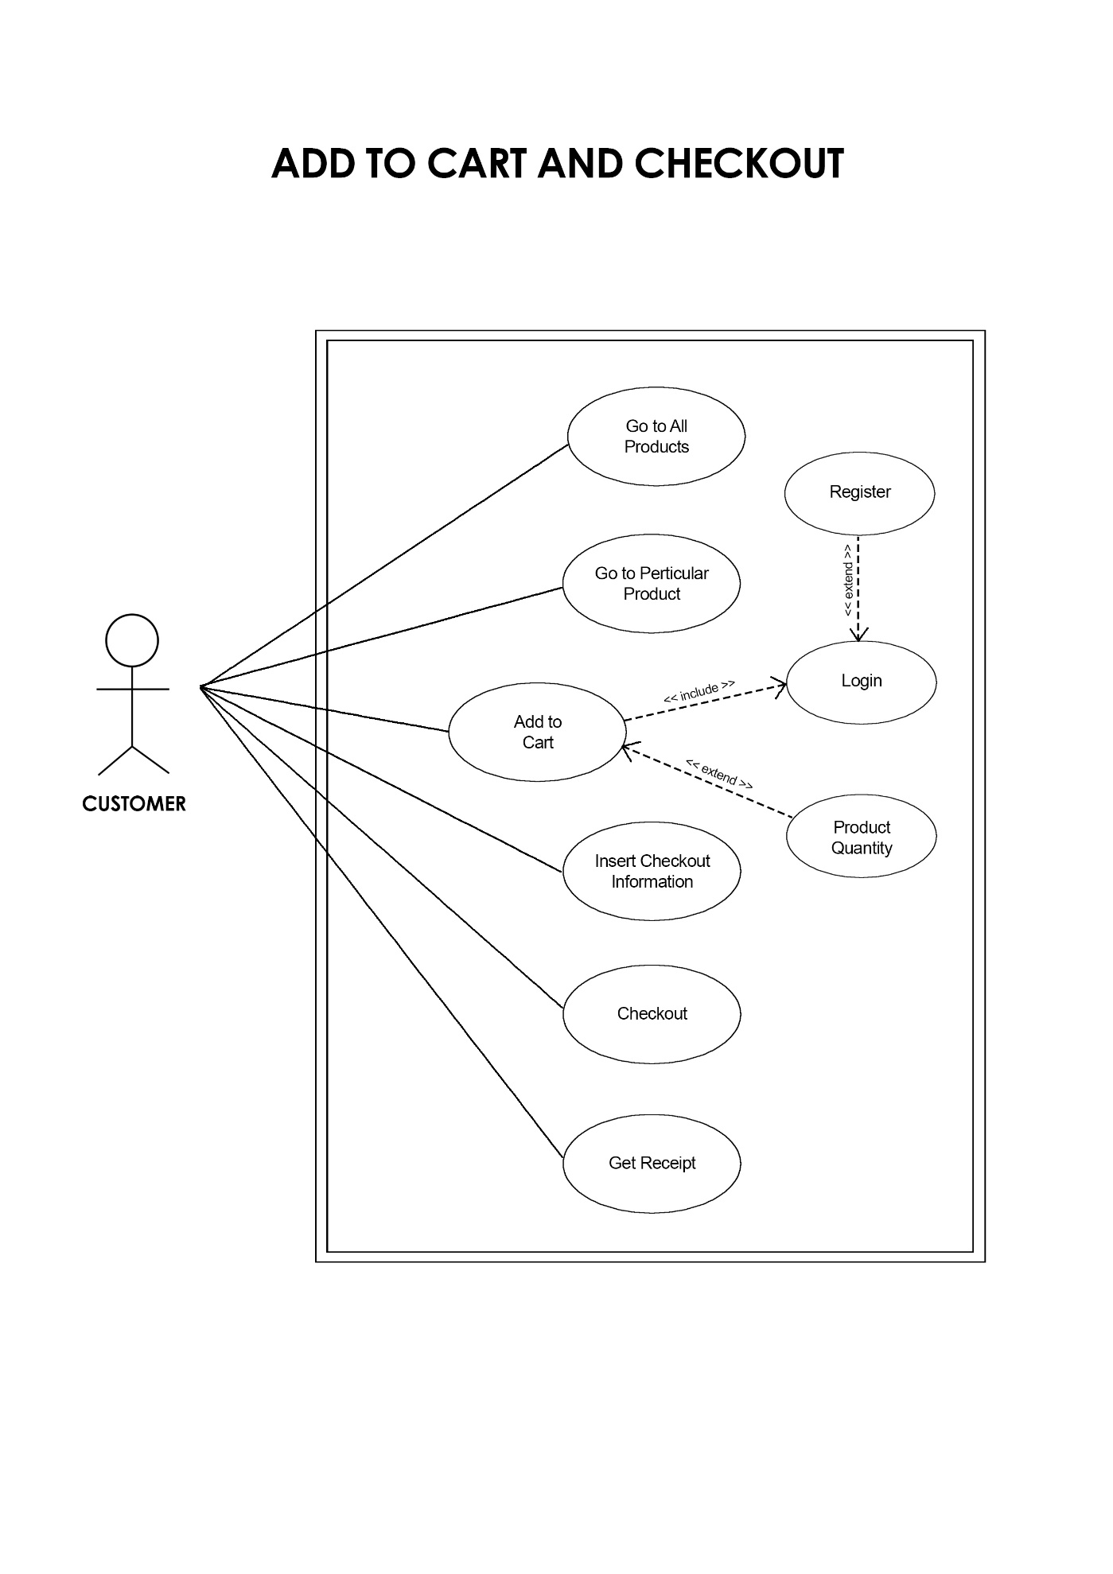

Use Case Realization

1. Admin Login

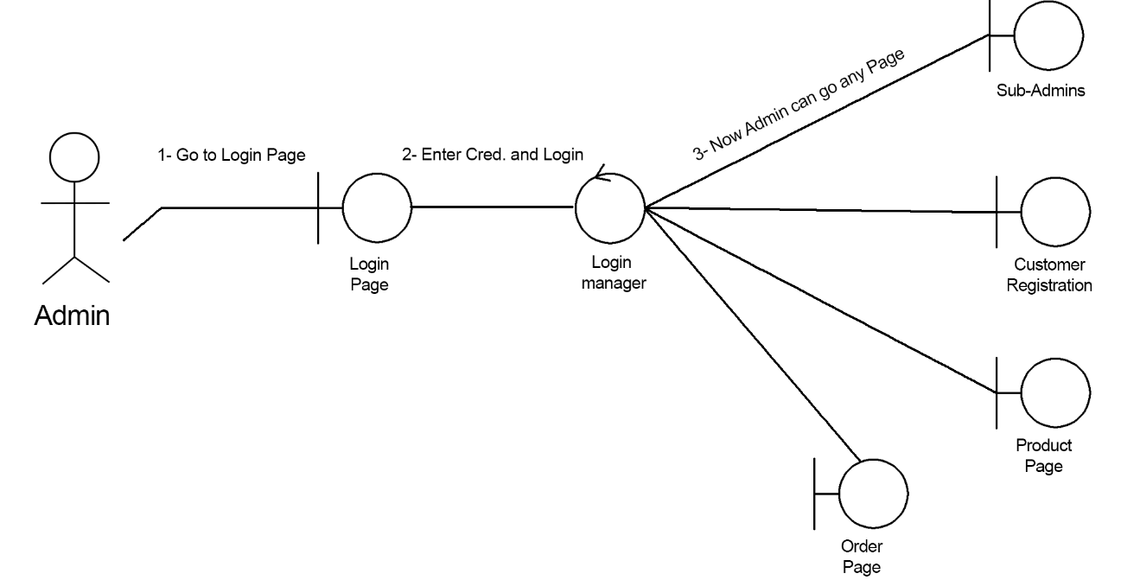

1. Sub-Admin Login

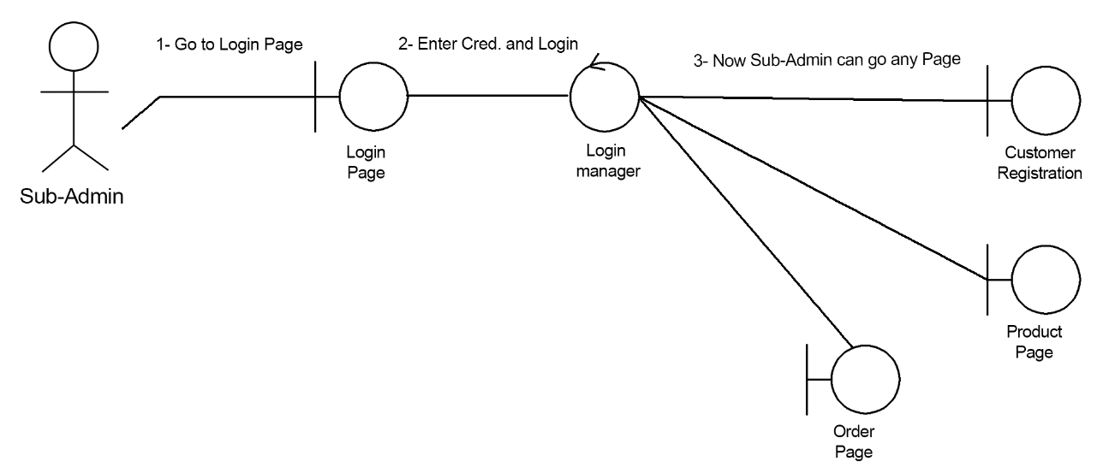

1. Get Sub-Admin

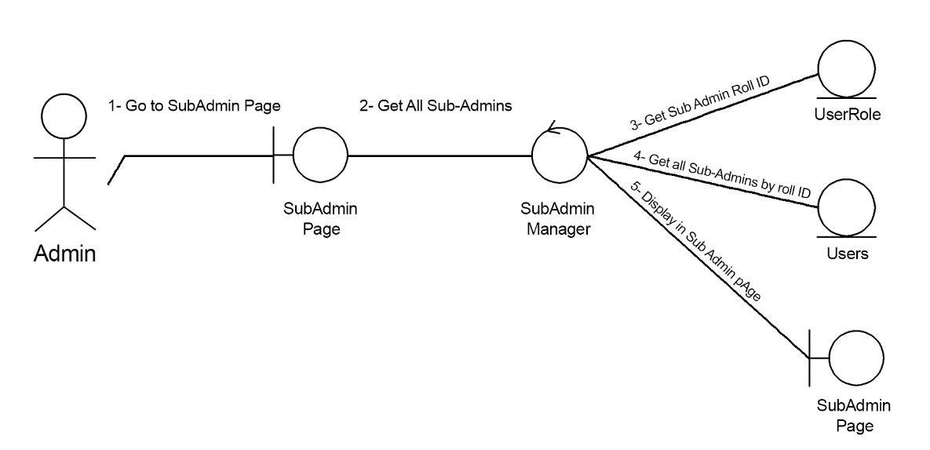

1. Add Sub-Admin

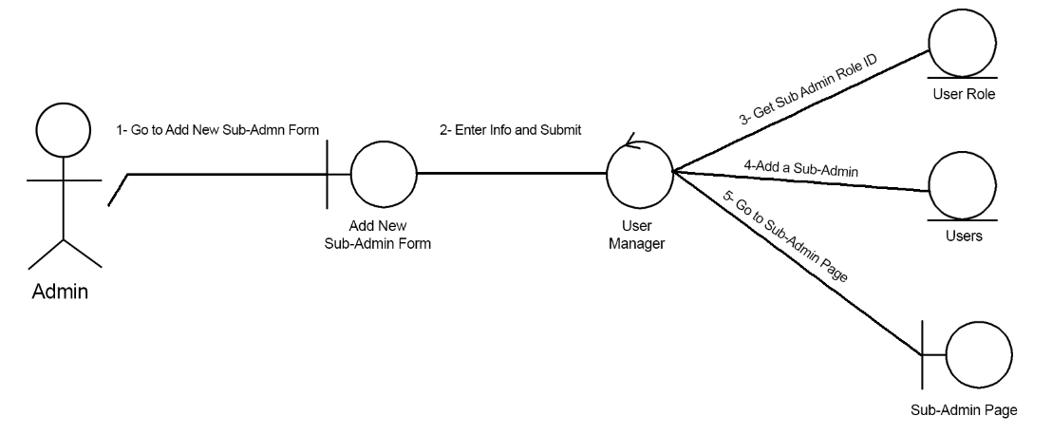

1. Edit Sub-Admin

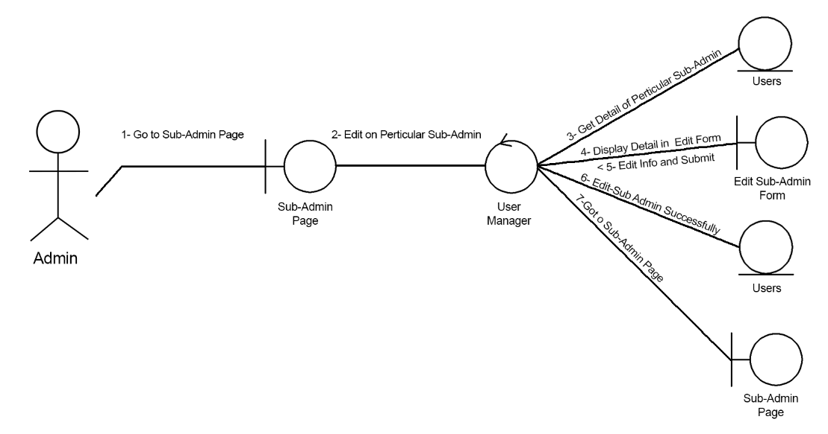

1. Delete Sub-Admin

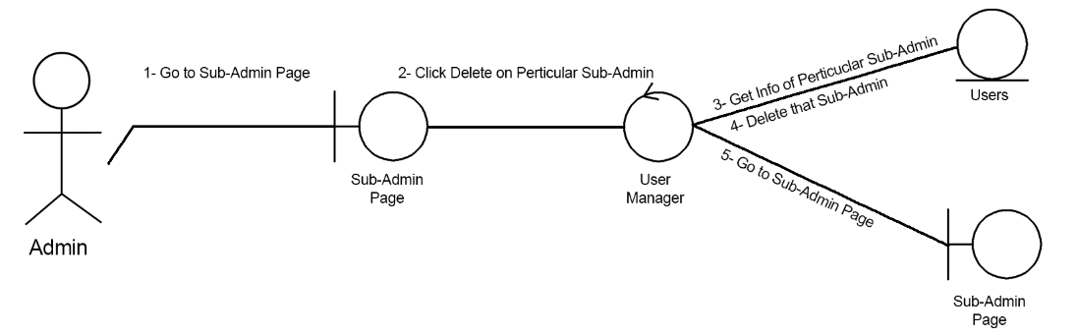

1. Get All Customers

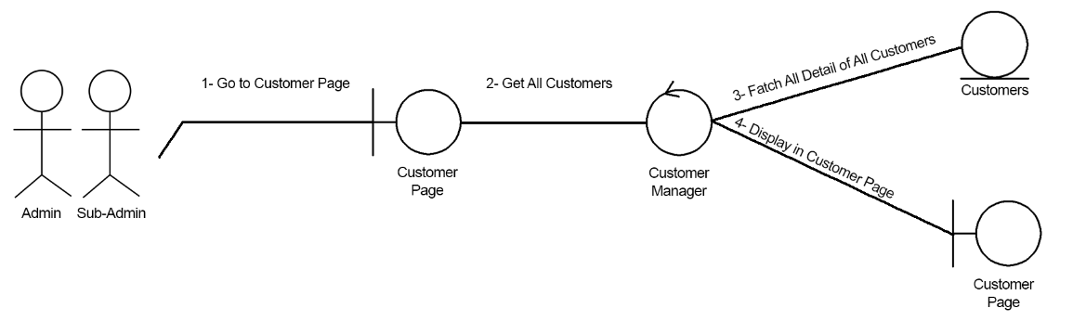

1. Add New Customer

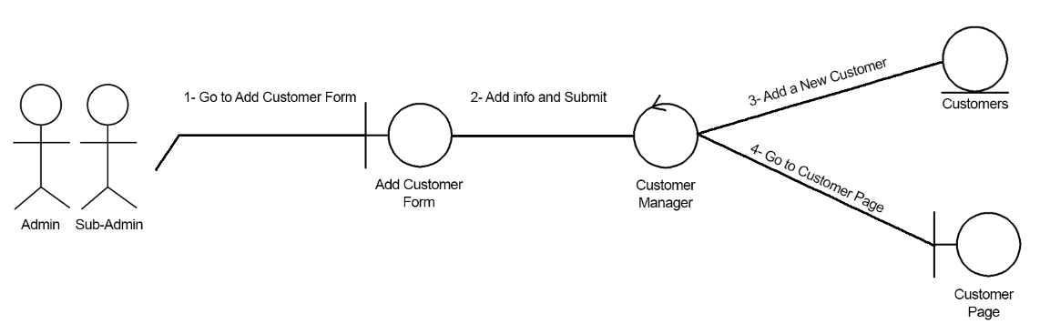

1. Edit Customer Info

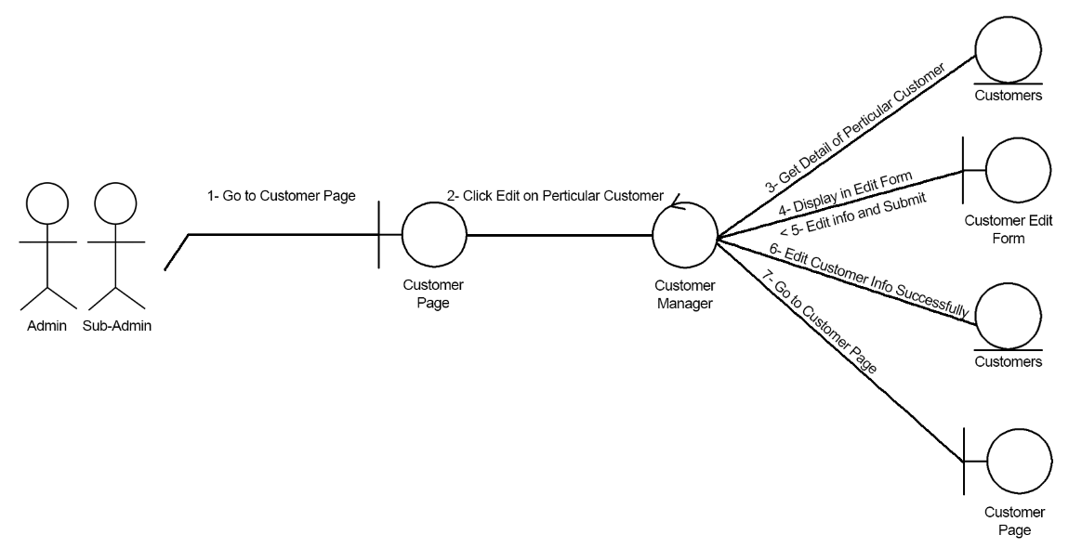

1. Delete Customer

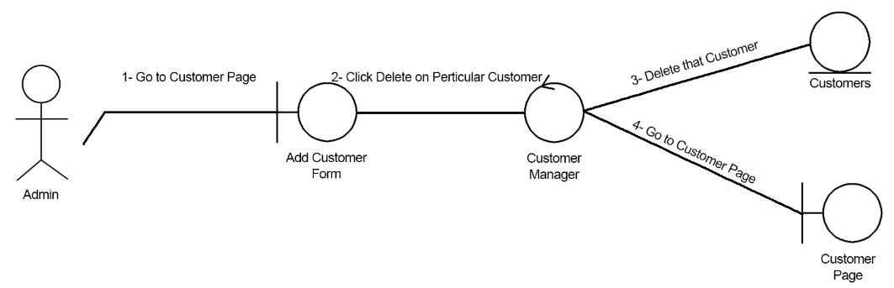

1. Customer Registration Himself

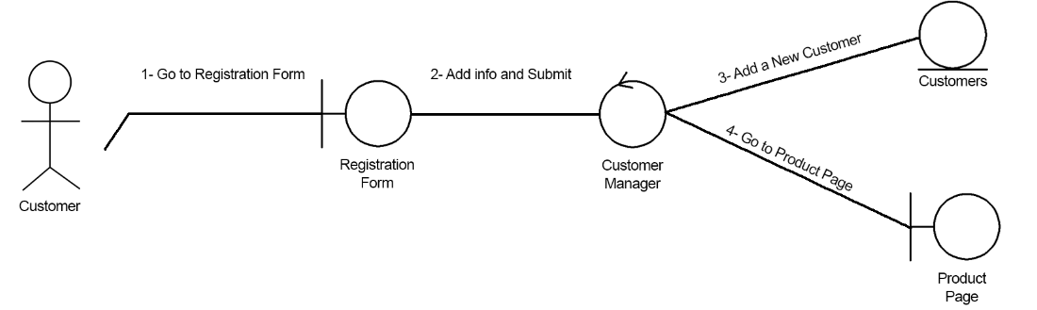

1. Get All Products

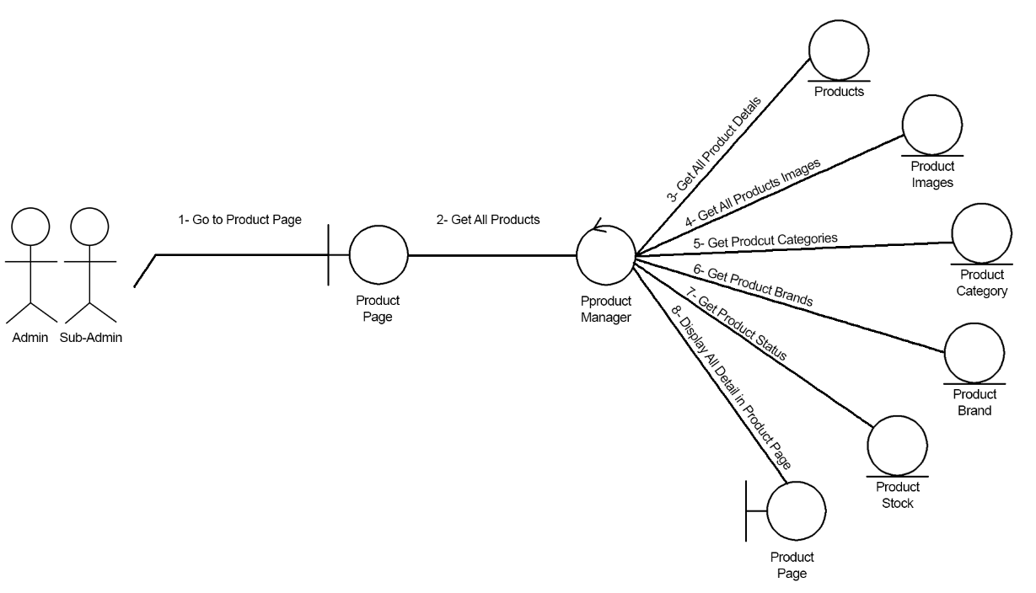

1. Add New Product

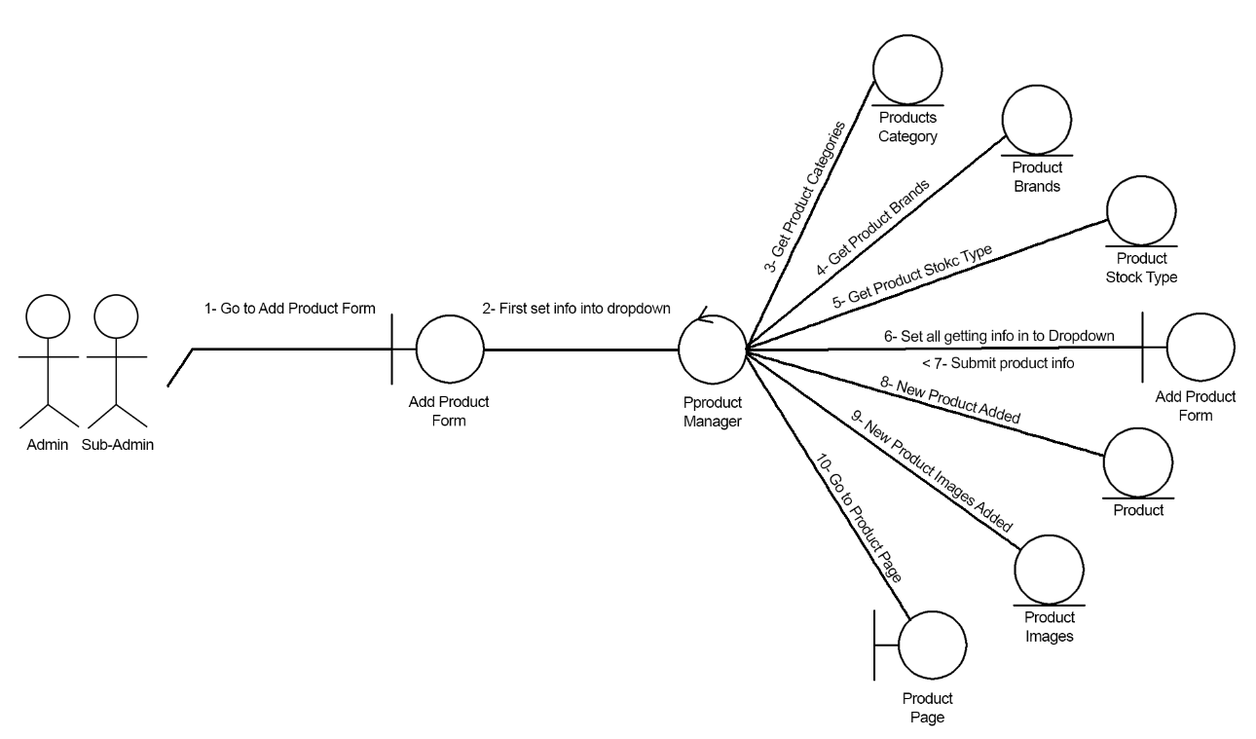

1. Edit Product

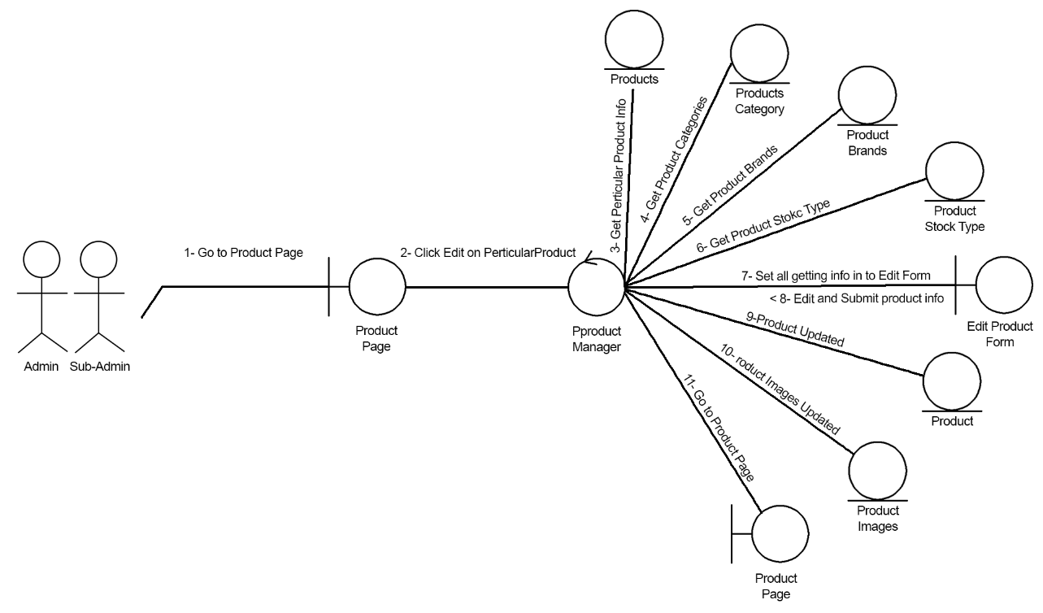

1. Delete Product

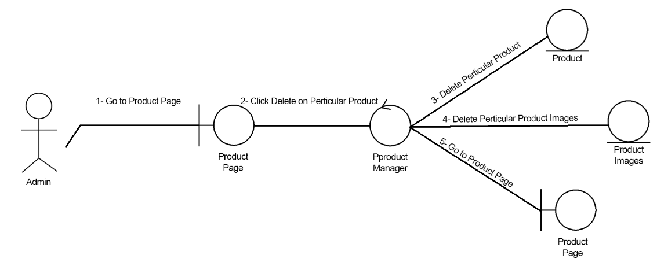

1. Get All Order

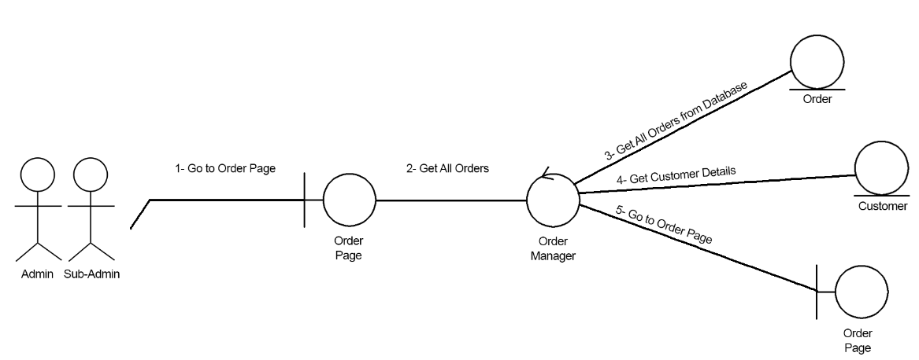

1. Get Particular Order

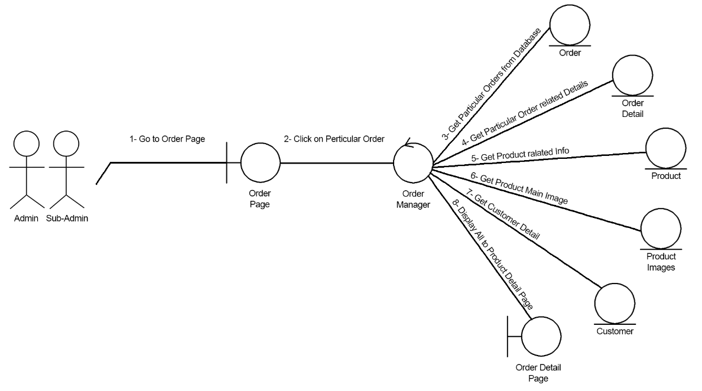

1. Change Order Status

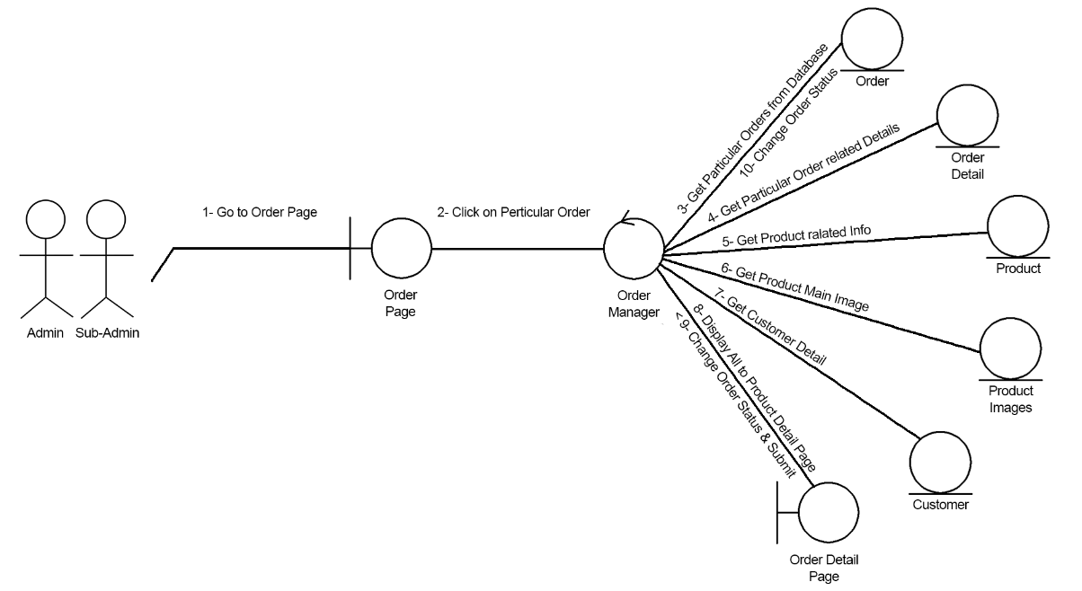

1. Get All Product by Customer

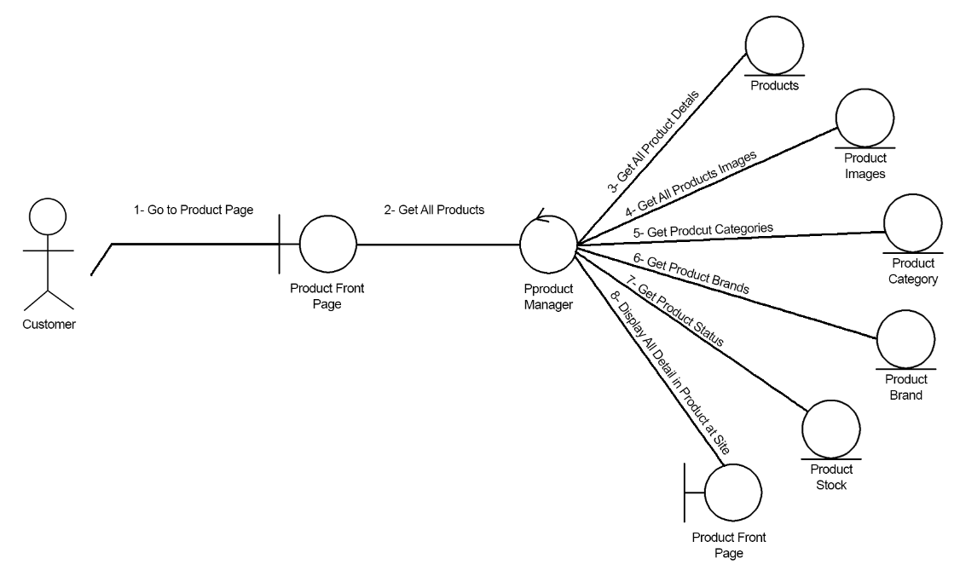

1. Get Product Detail by Customer

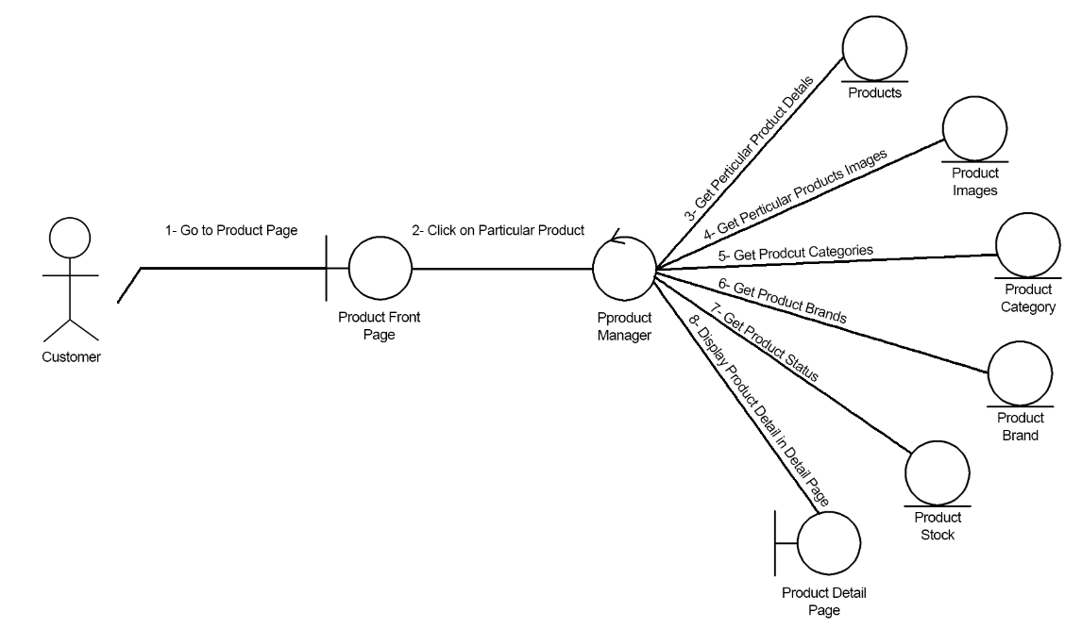

1. Customer Login

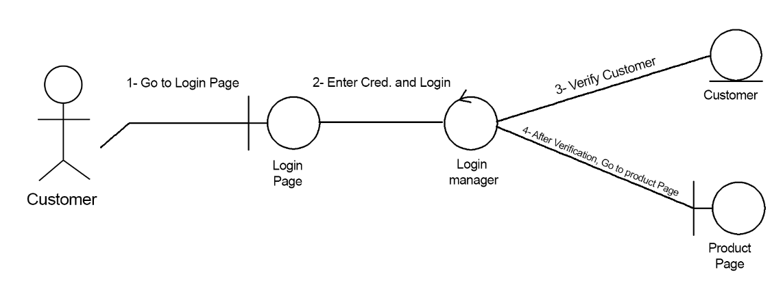

1. Add to Cart and Checkout

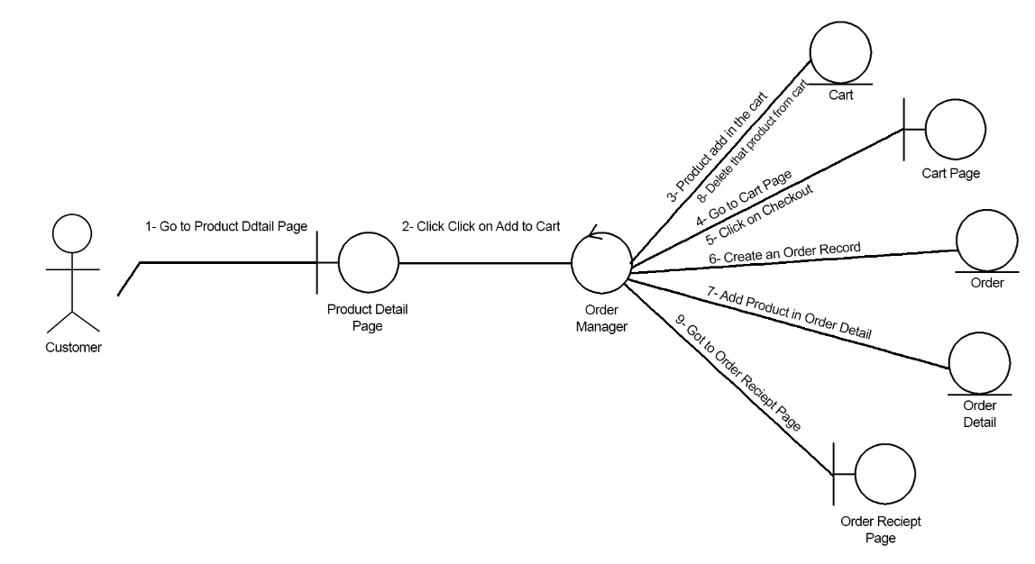

Activity Diagram

1. Add New Sub-Admin

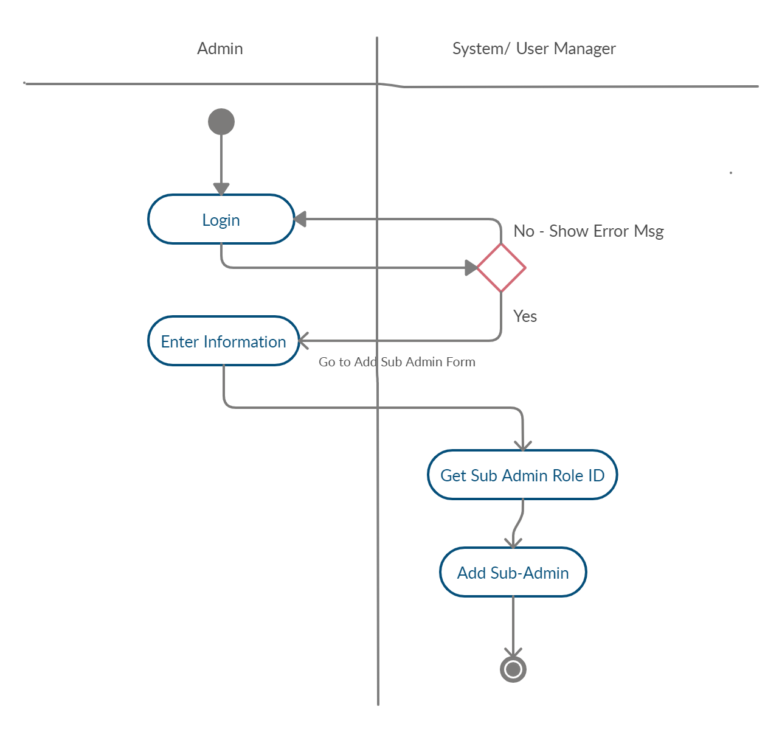

1. Edit Sub-Admin

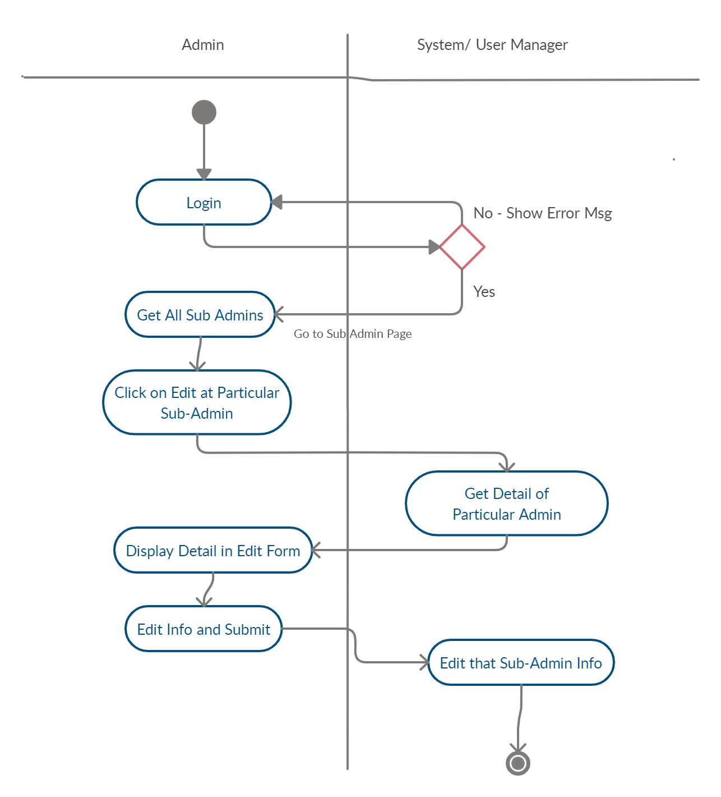

1. Delete Sub-Admin

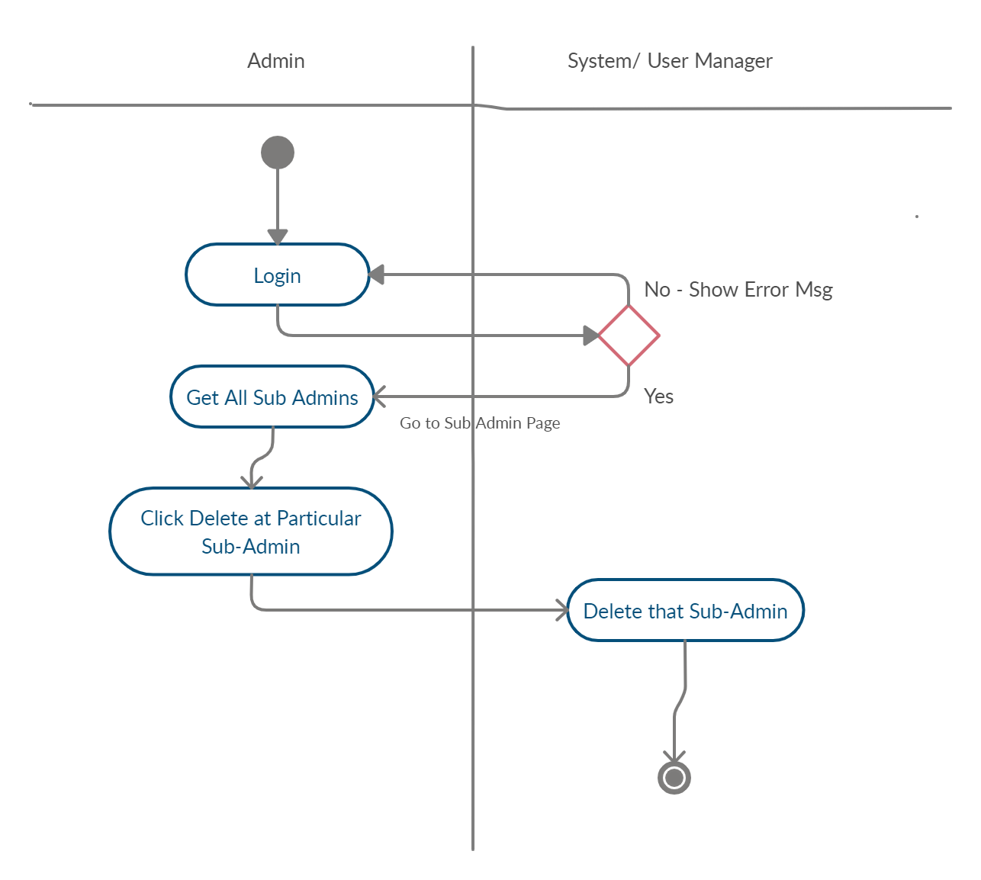

1. Add Customer

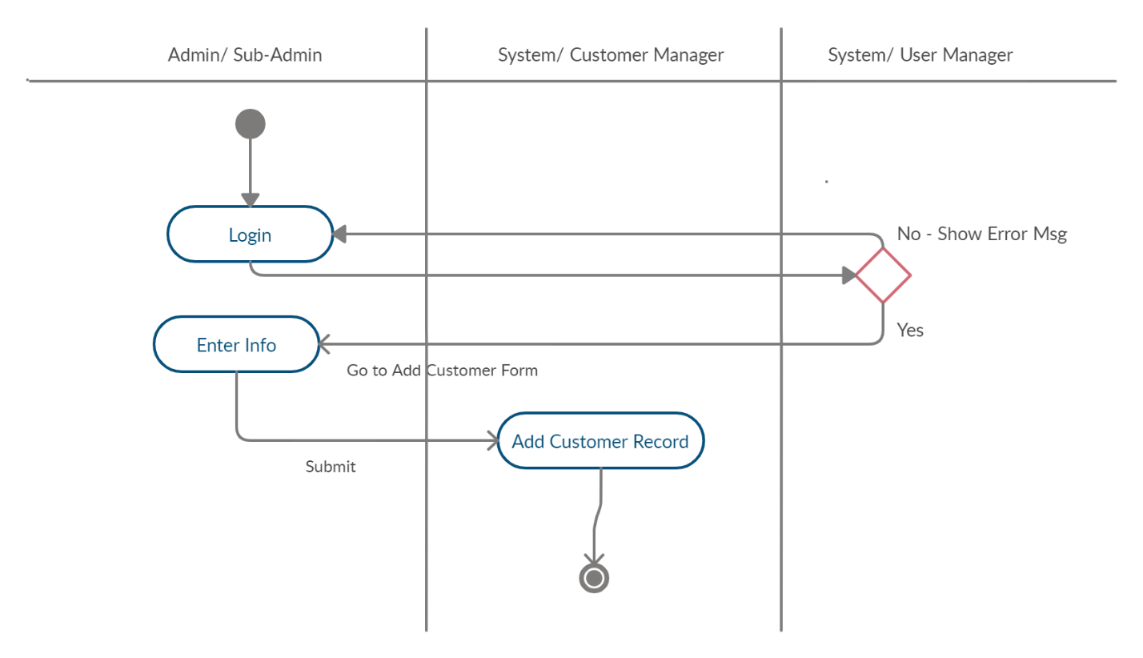

1. Delete Customer

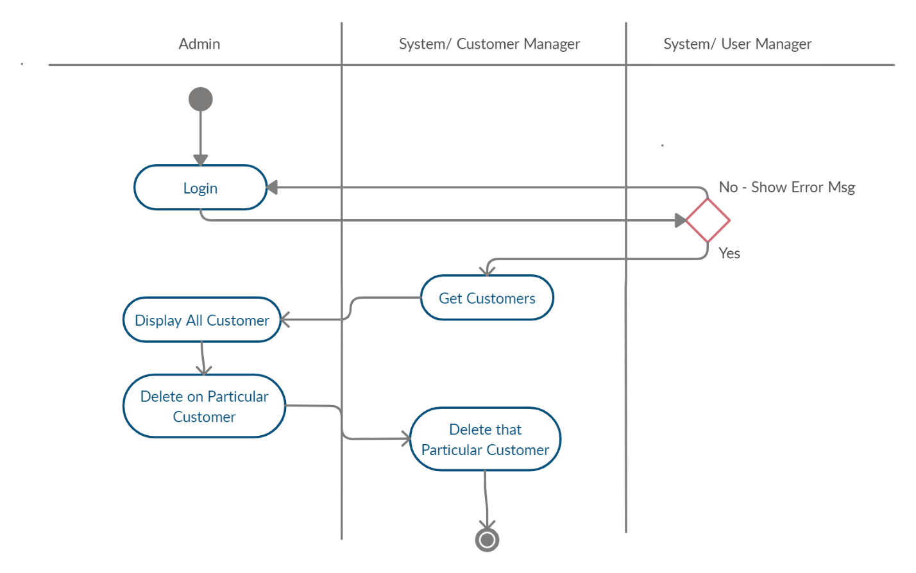

1. Edit Customer

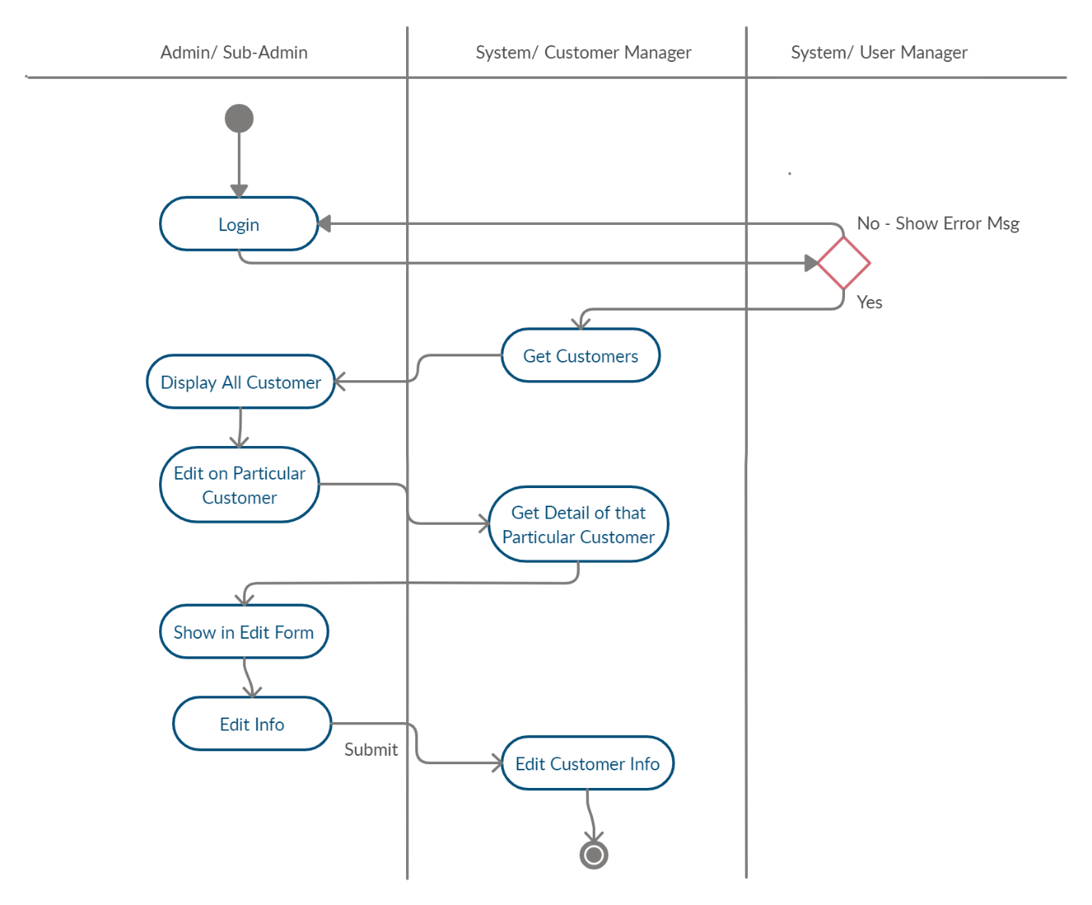

1. Add Product

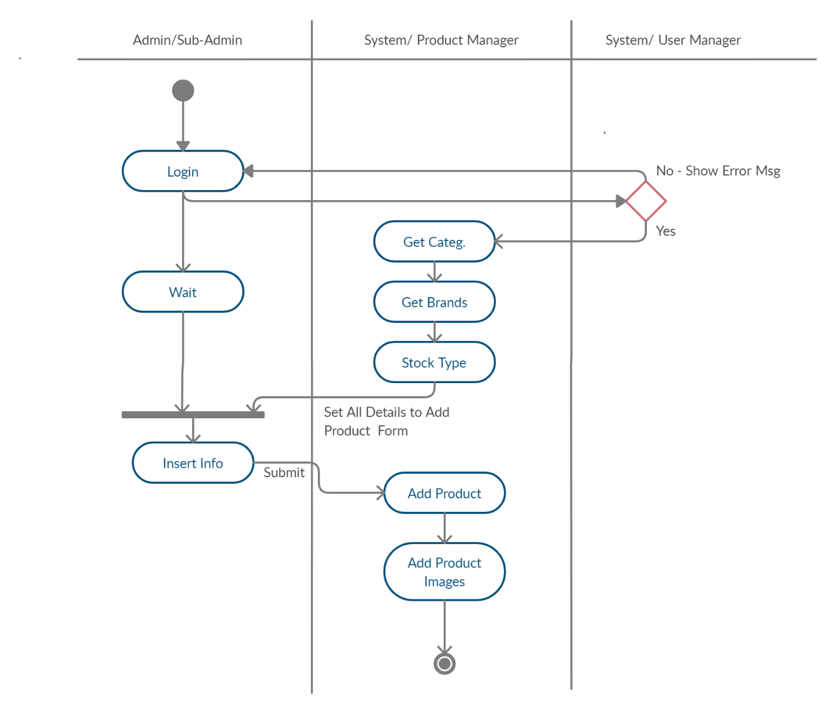

1. **Edit Product**

Particular

Product

Product

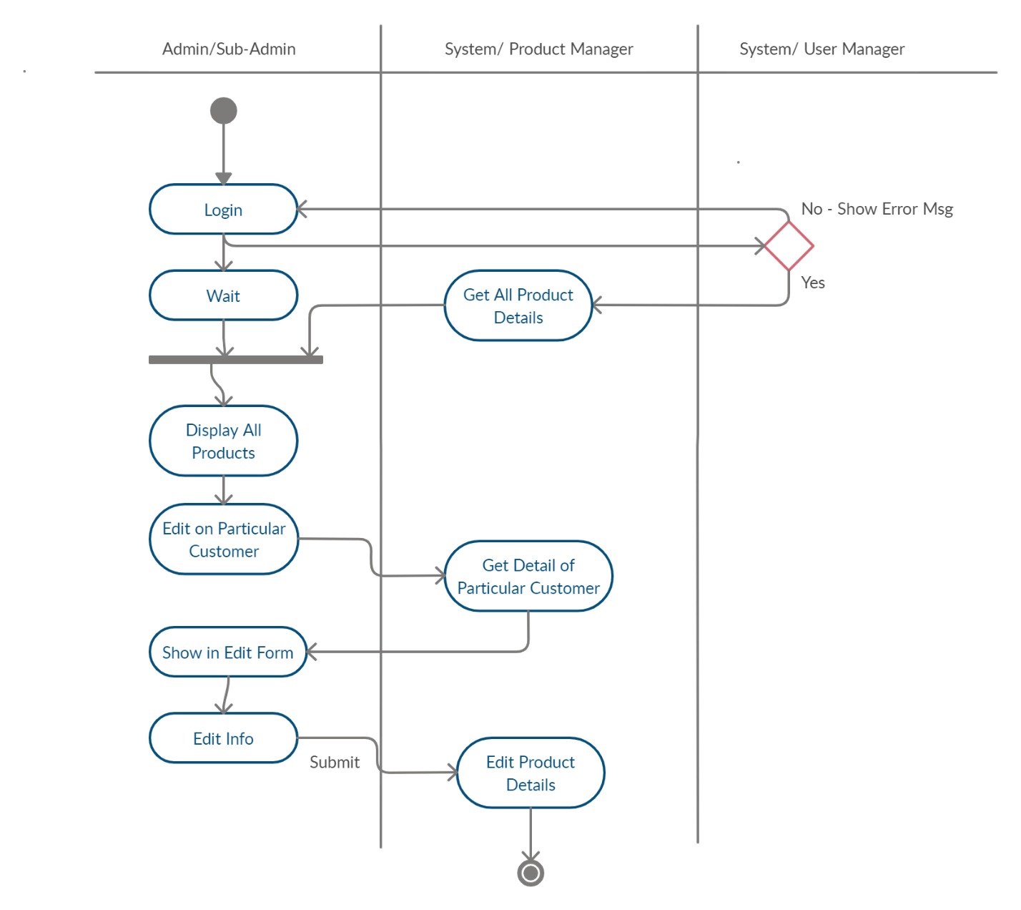

1. **Delete Product**

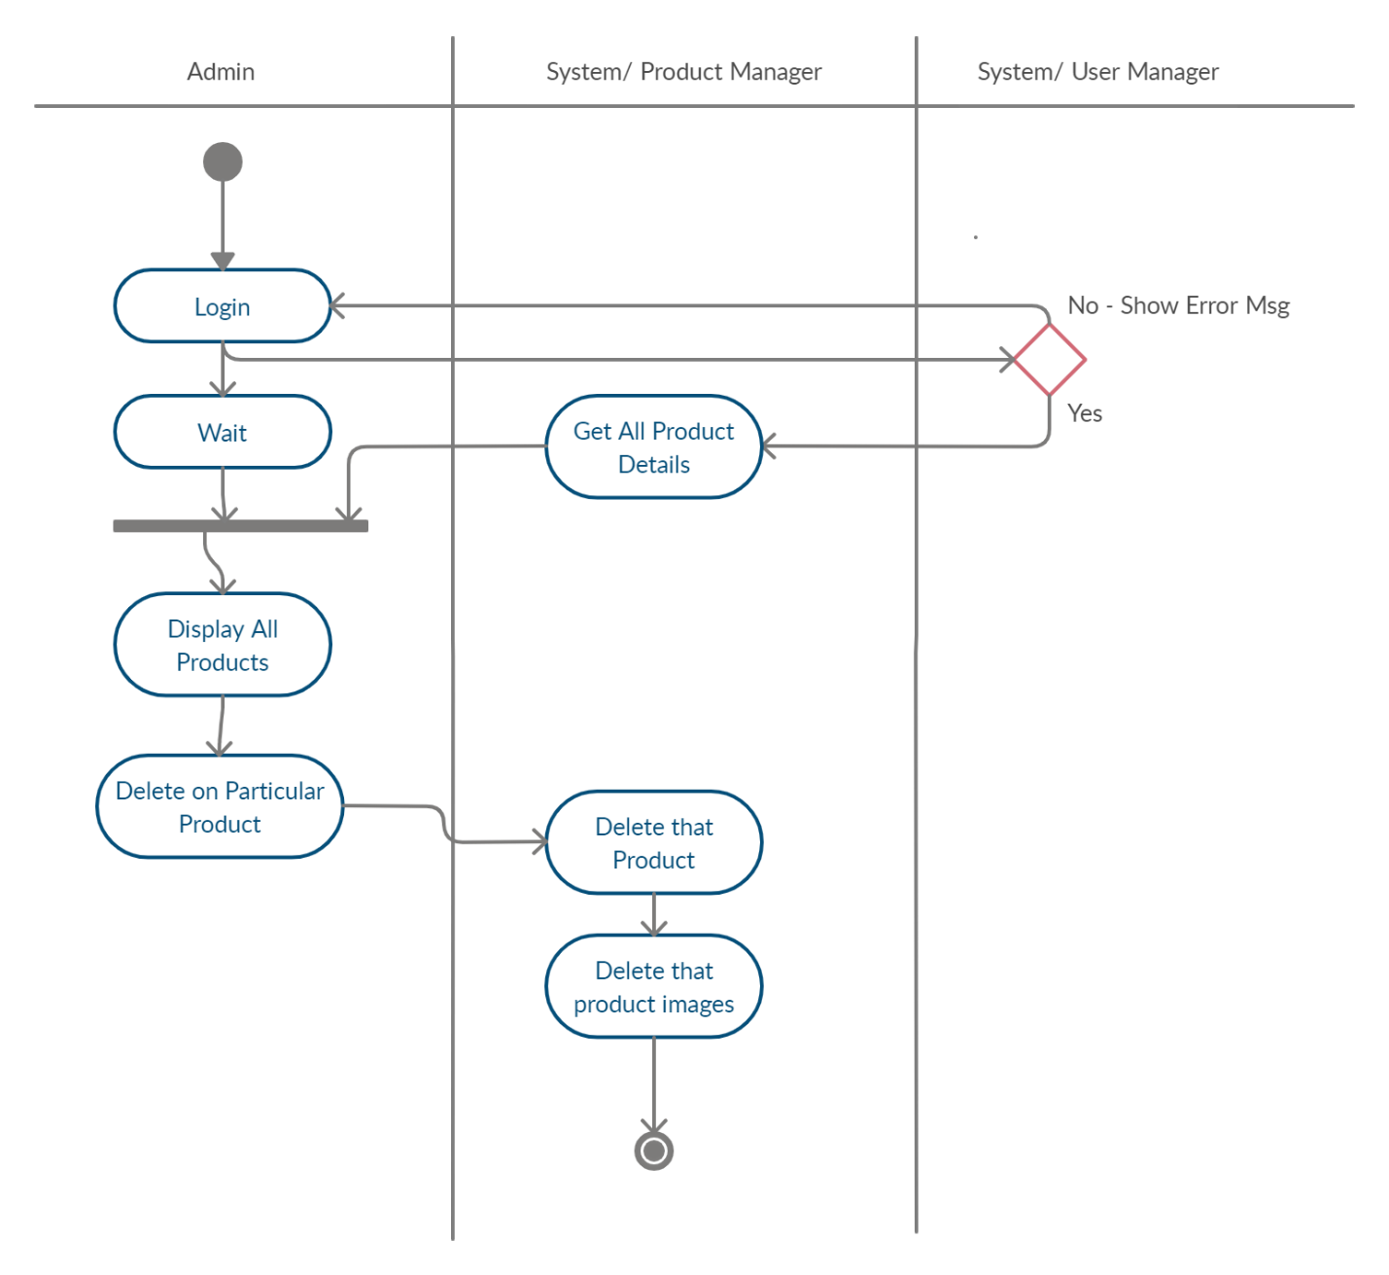

1. **Change Order Status**

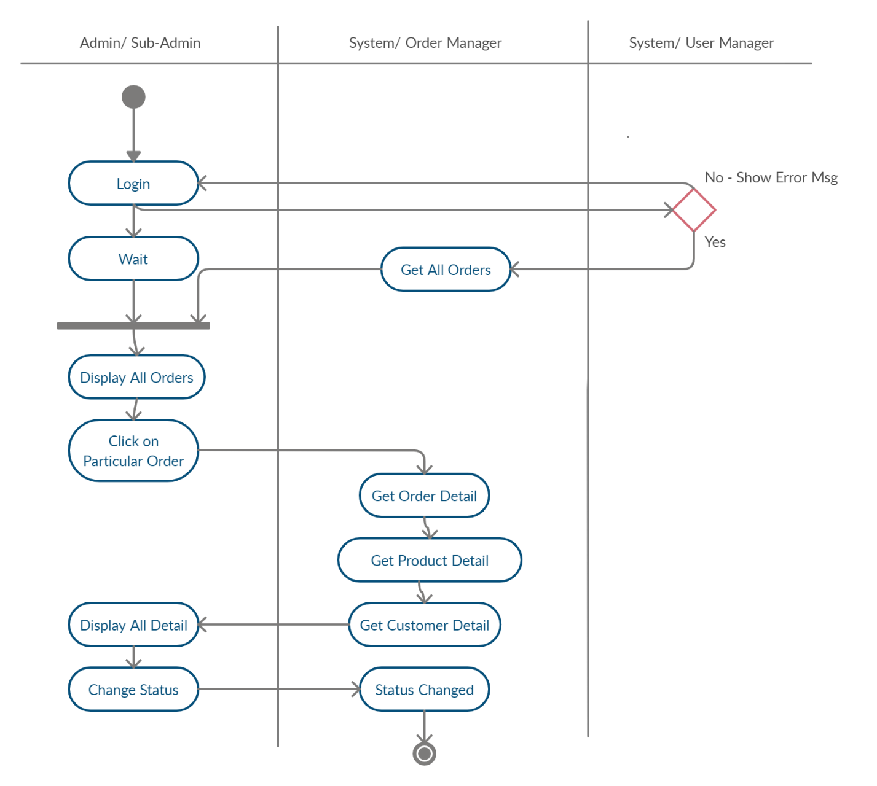

1. **Add to Cart and Checkout**

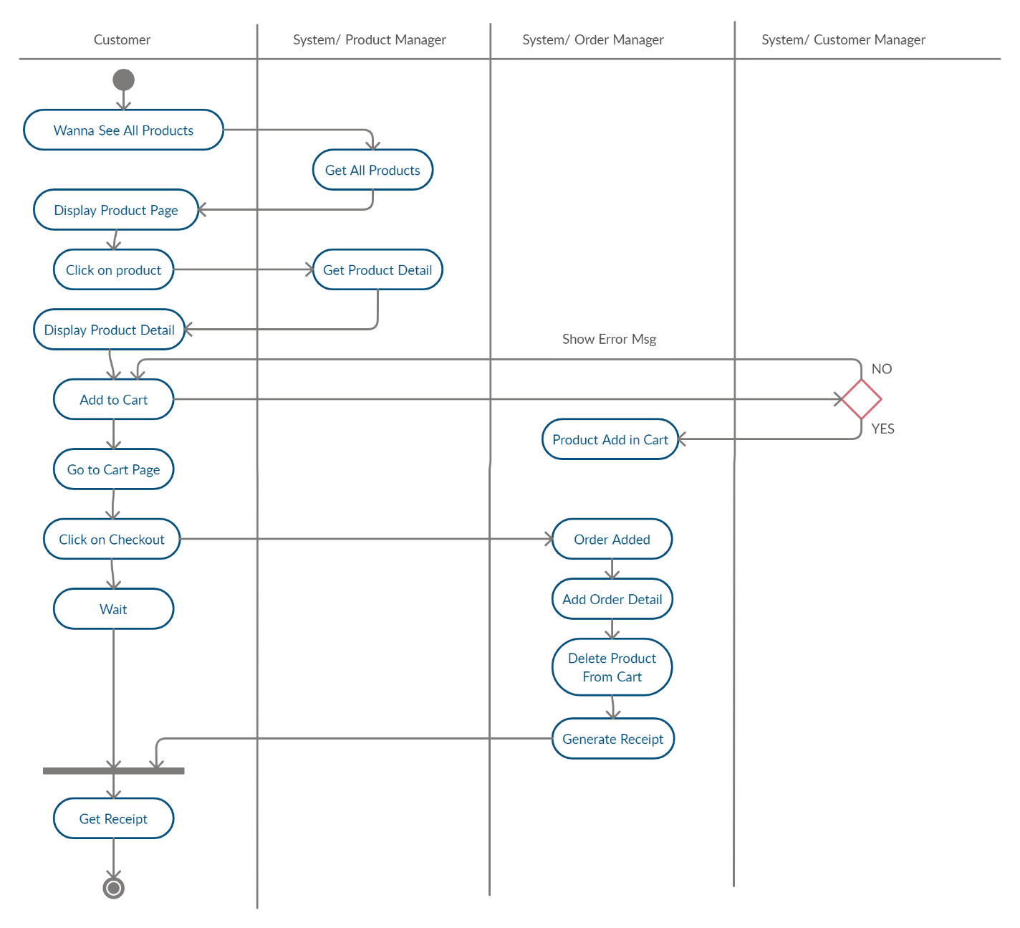

**Class Diagram**

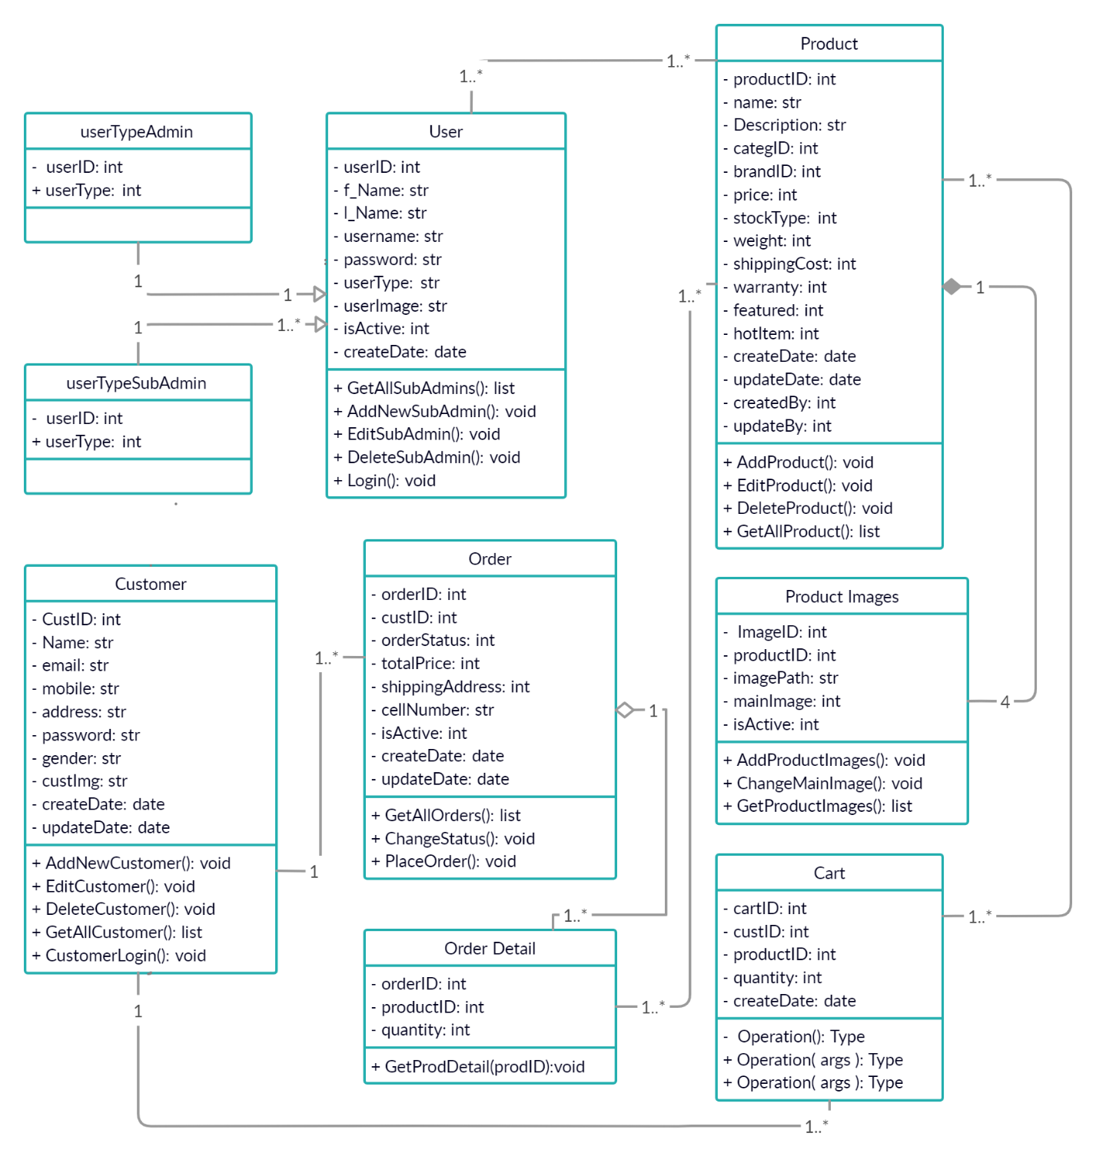

**Sequence Diagram**

1. **Sub-Admin CRUD**

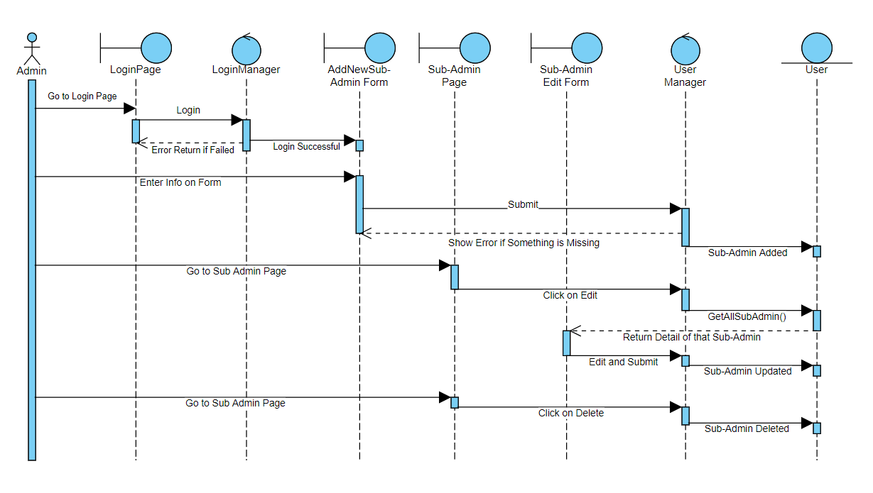

1. **Add and Edit Customer**

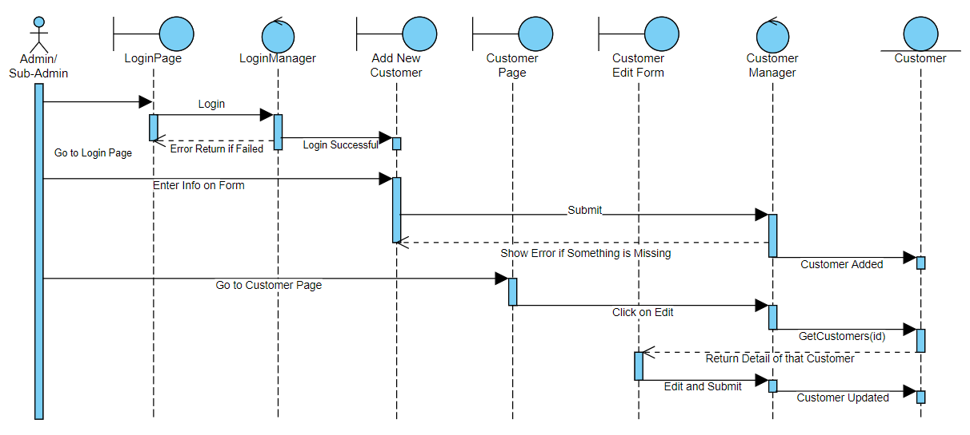

1. **Delete Customer**

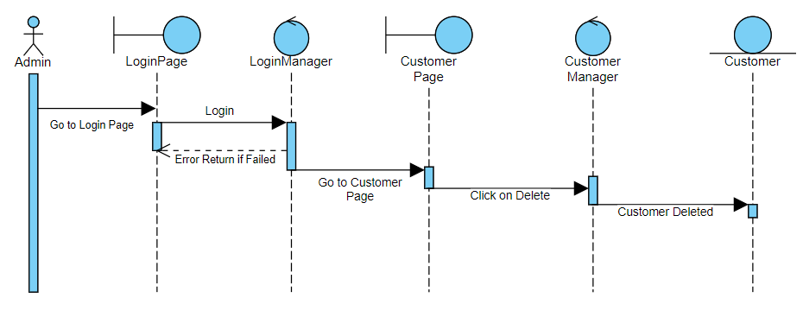

1. **Add Product**

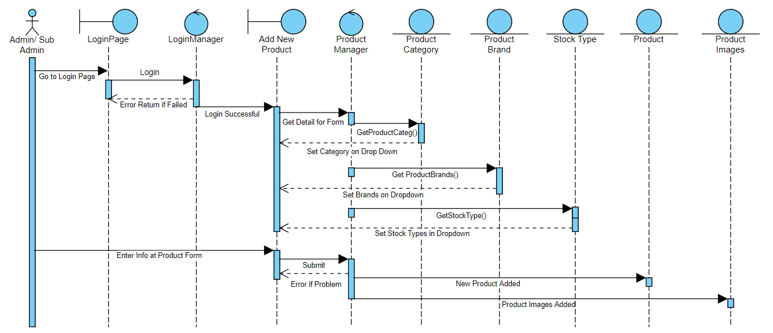

1. **Edit Product**

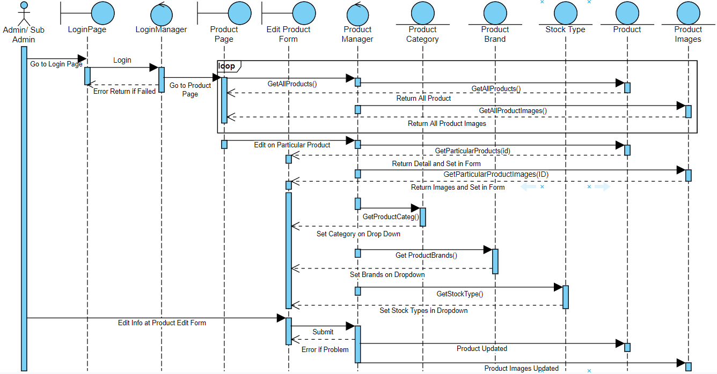

1. **Delete Product**

Admin

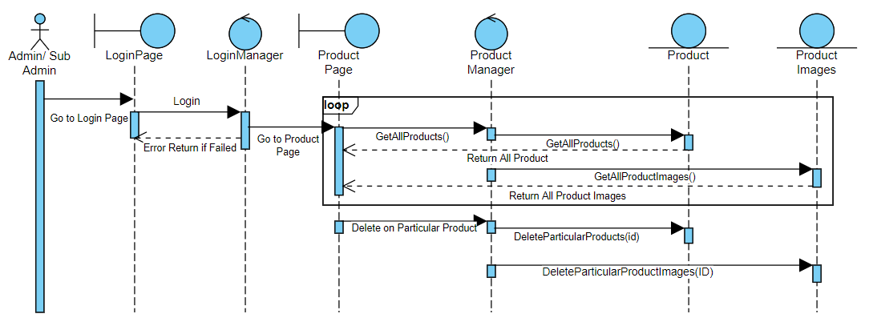

1. **Change Order Status**

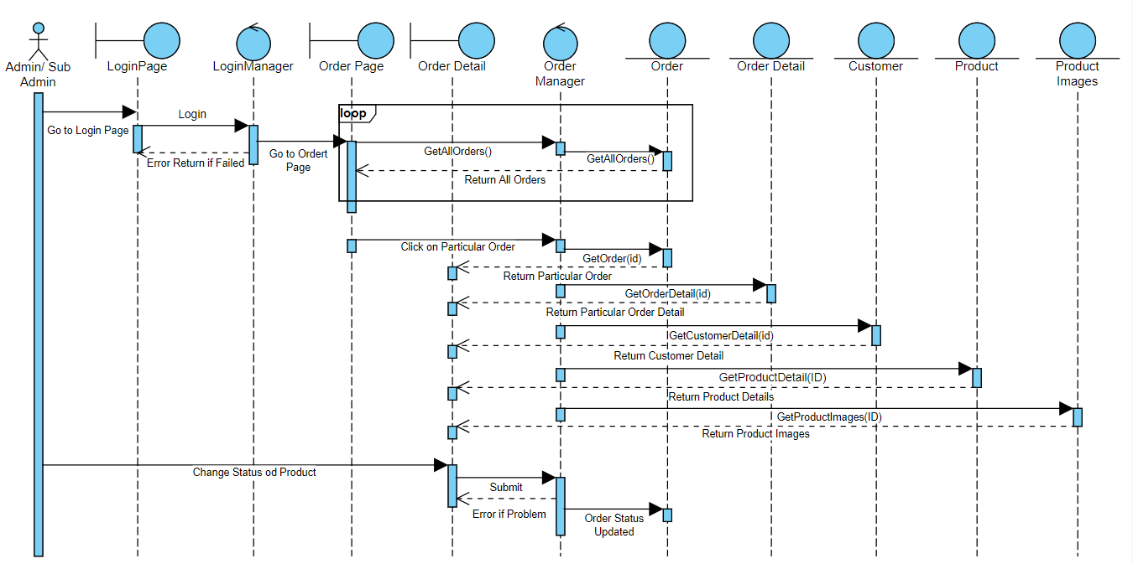

1. **Add to Cart and Checkout**

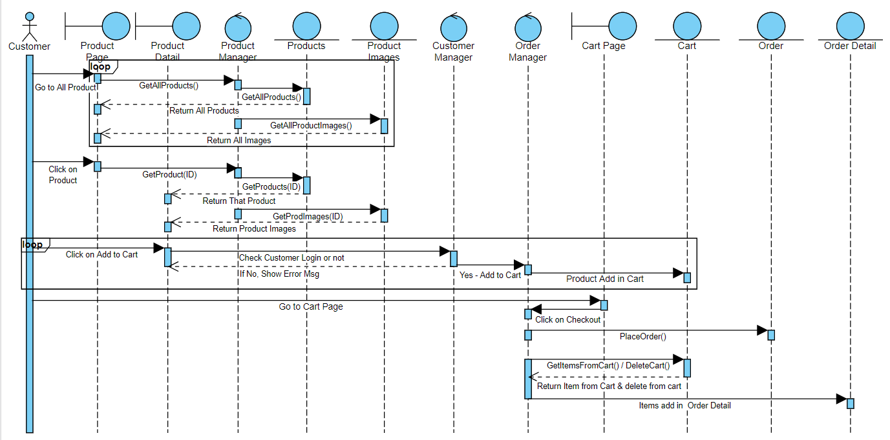

**Collaboration Diagram**

1. **Add Sub-Admin**

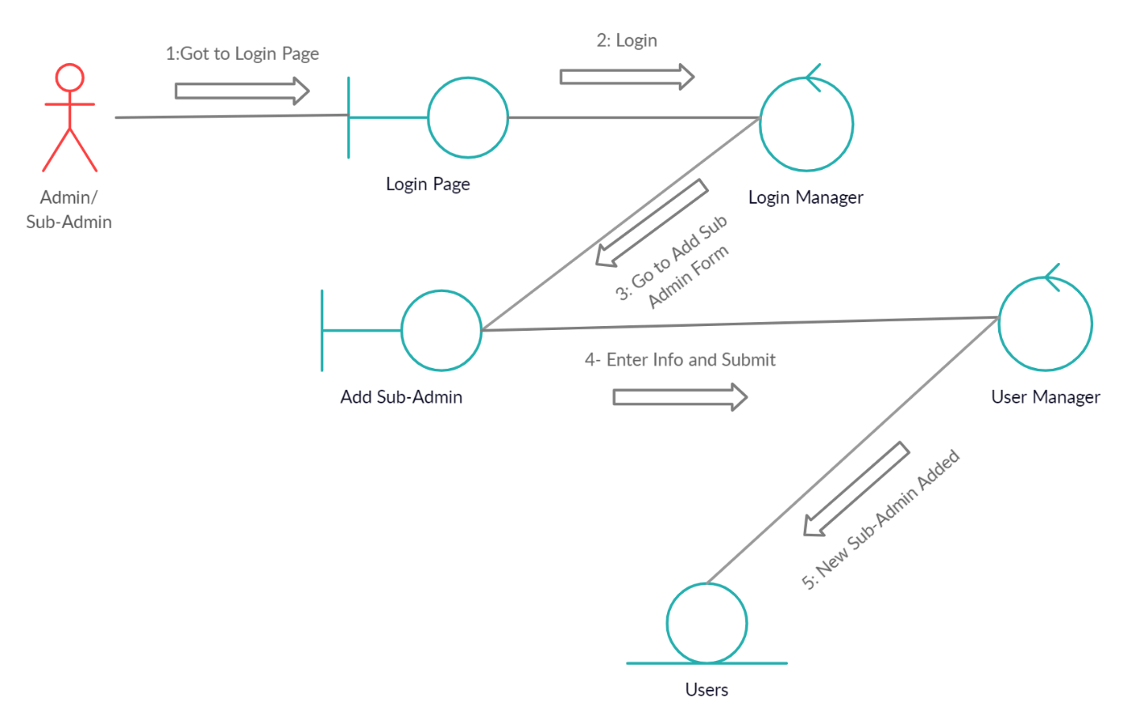

1. **Edit Sub-Admin**

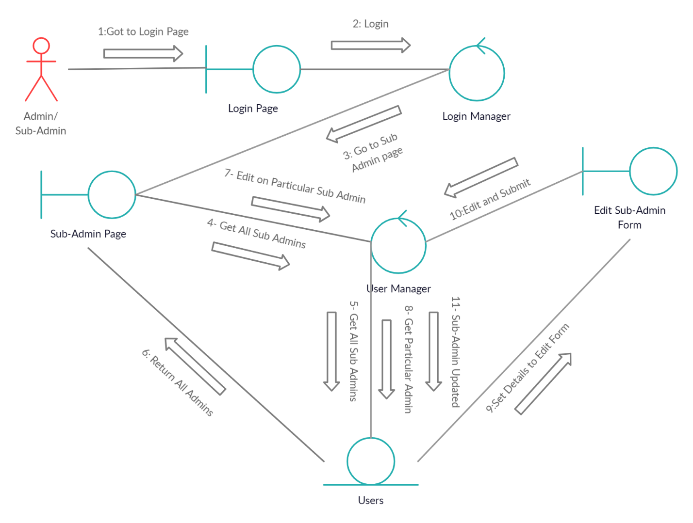

1. **Delete Sub-Admin**

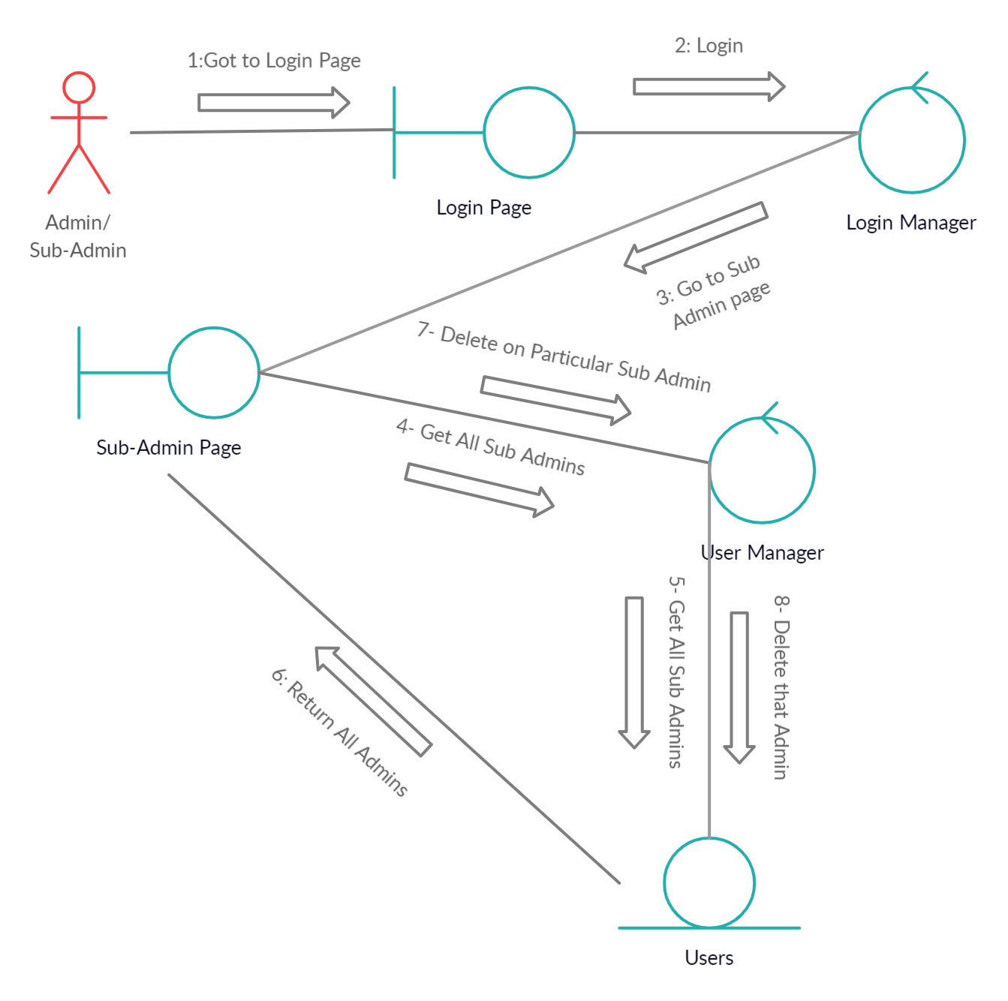

1. **Add Customer**

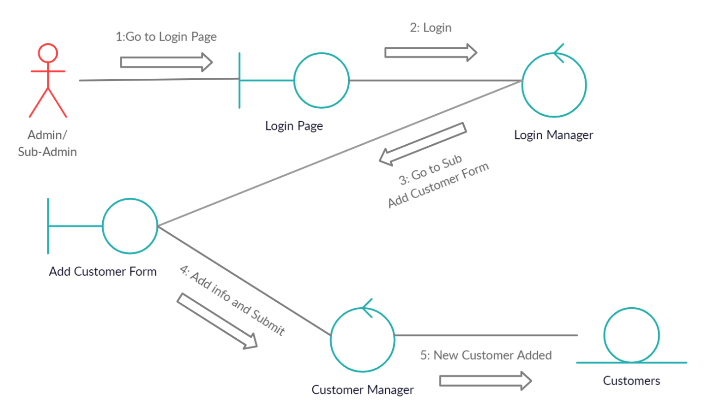

1. **Edit Customer**

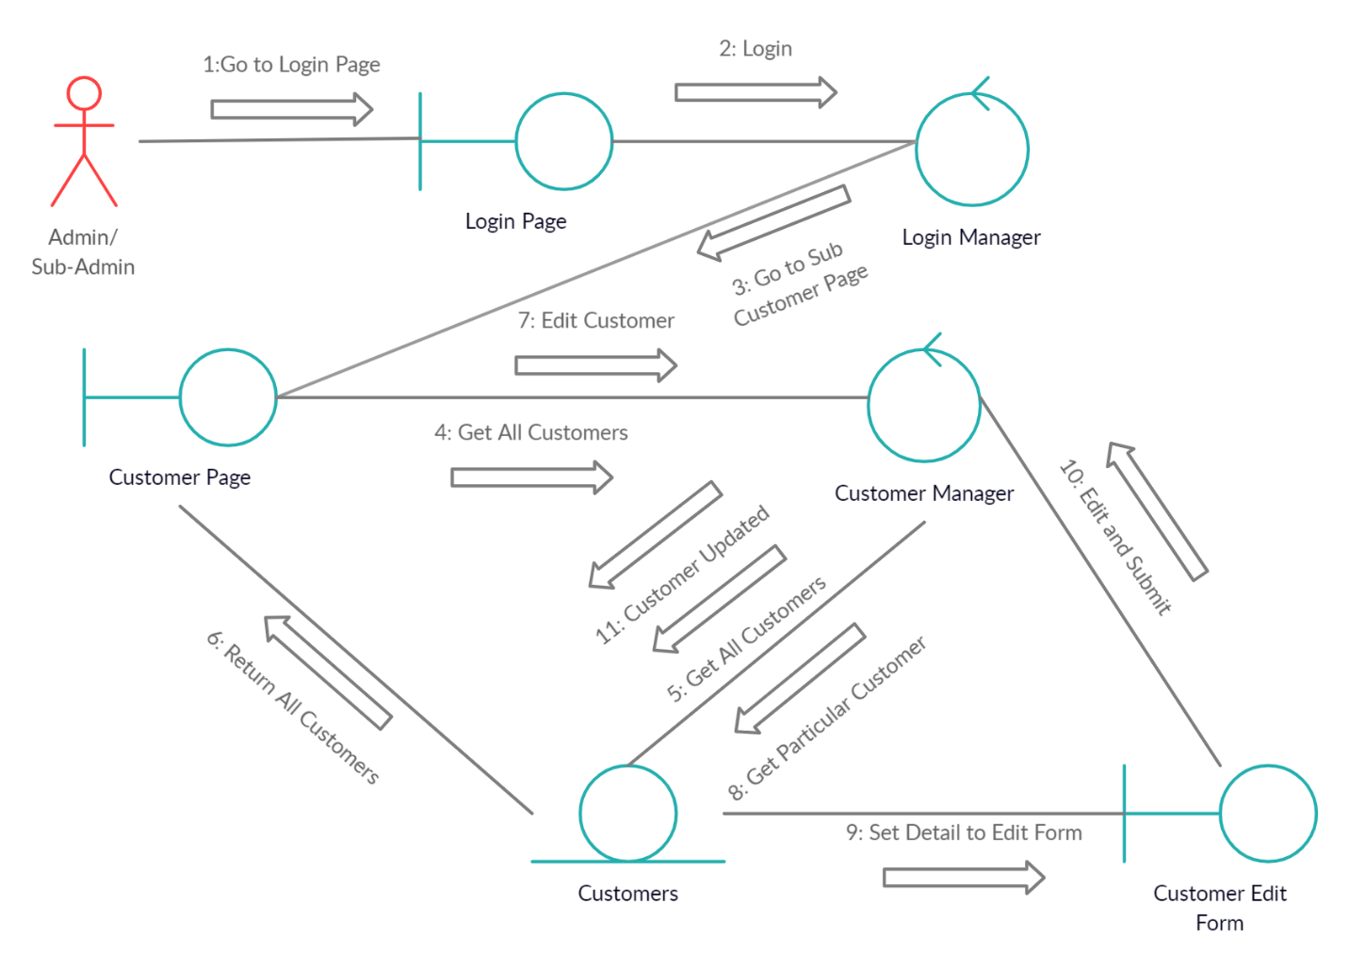

1. **Delete Customer**

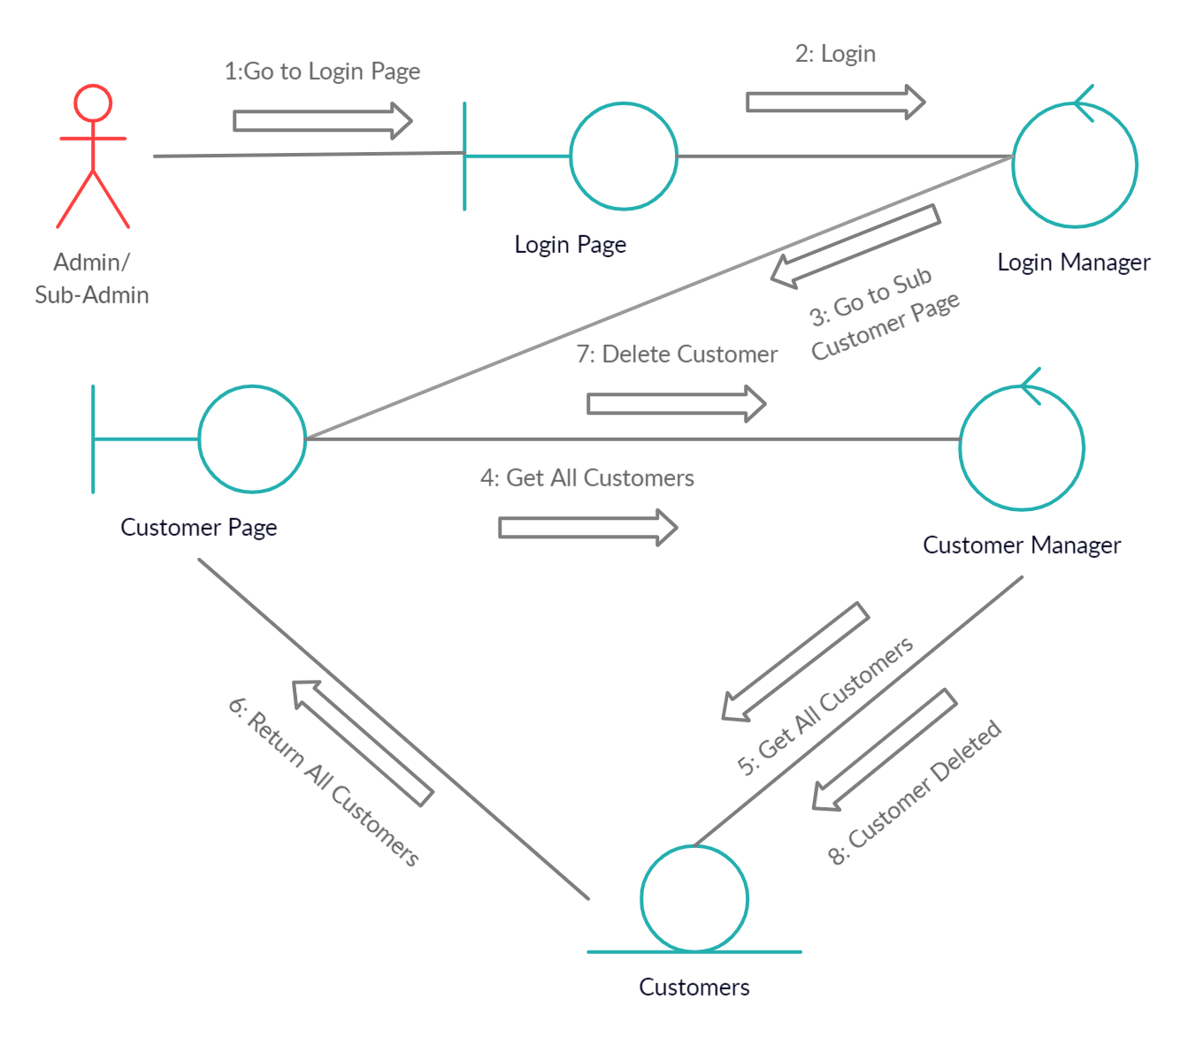

1. **Add Product**

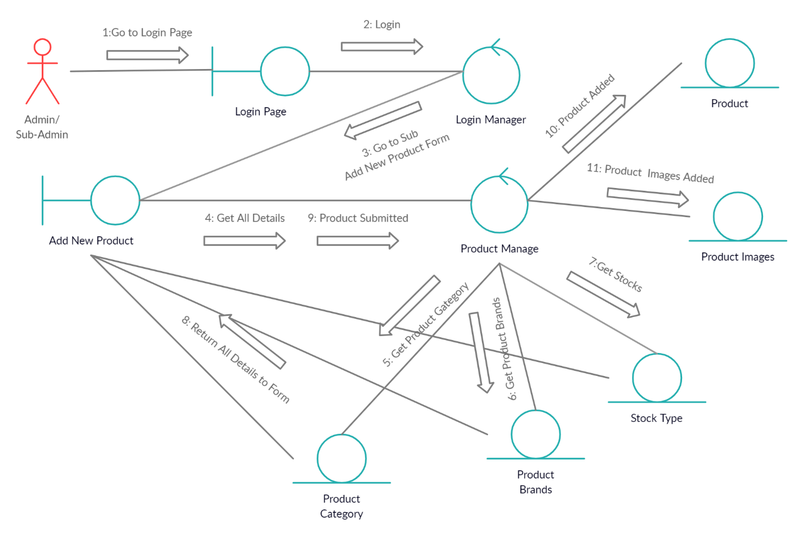

1. **Edit Product**

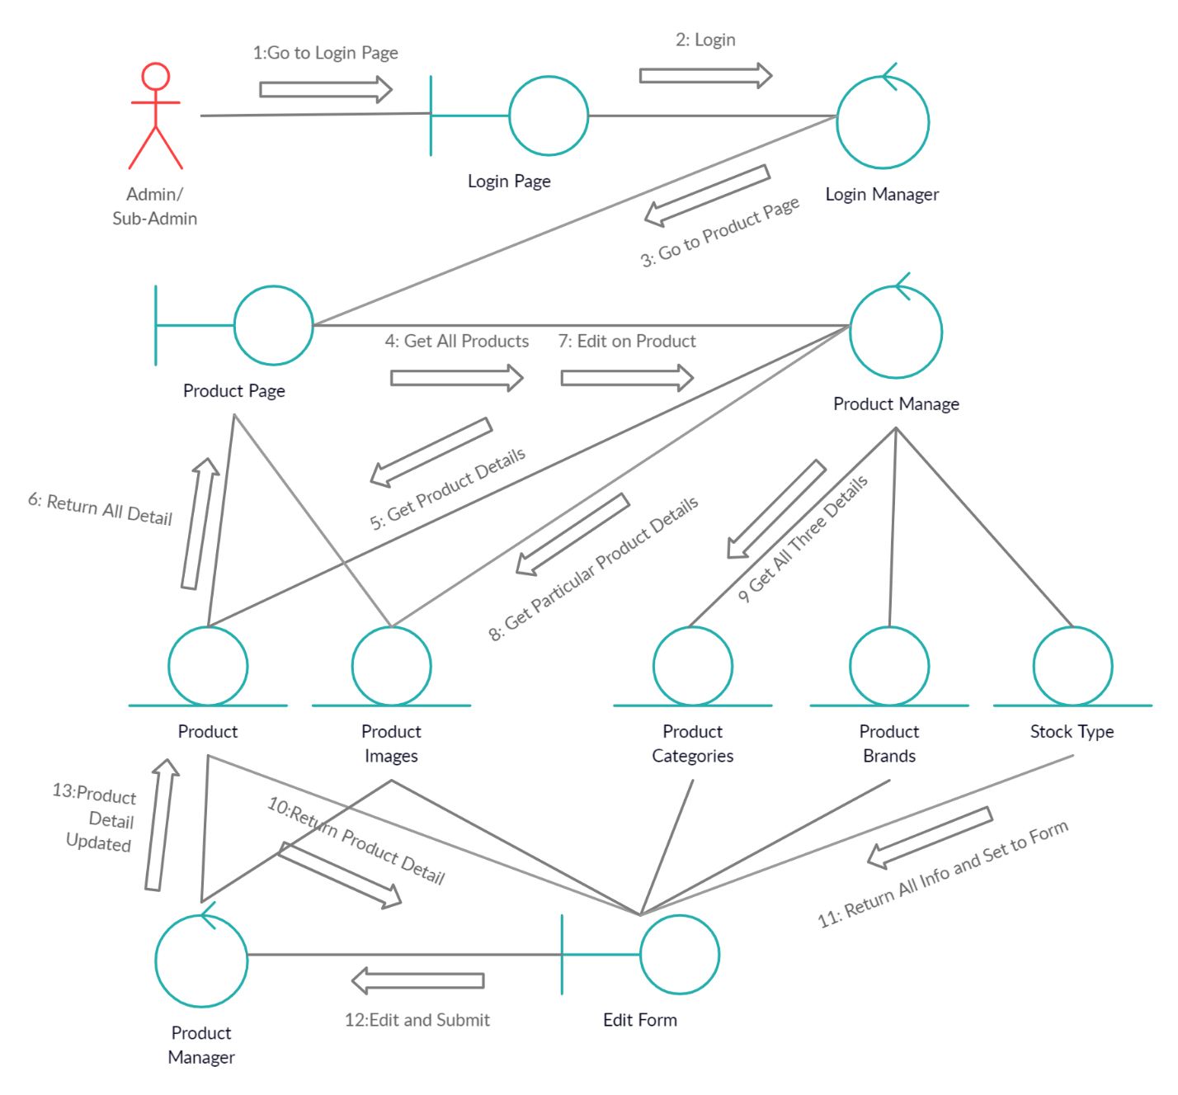

1. **Delete Product**

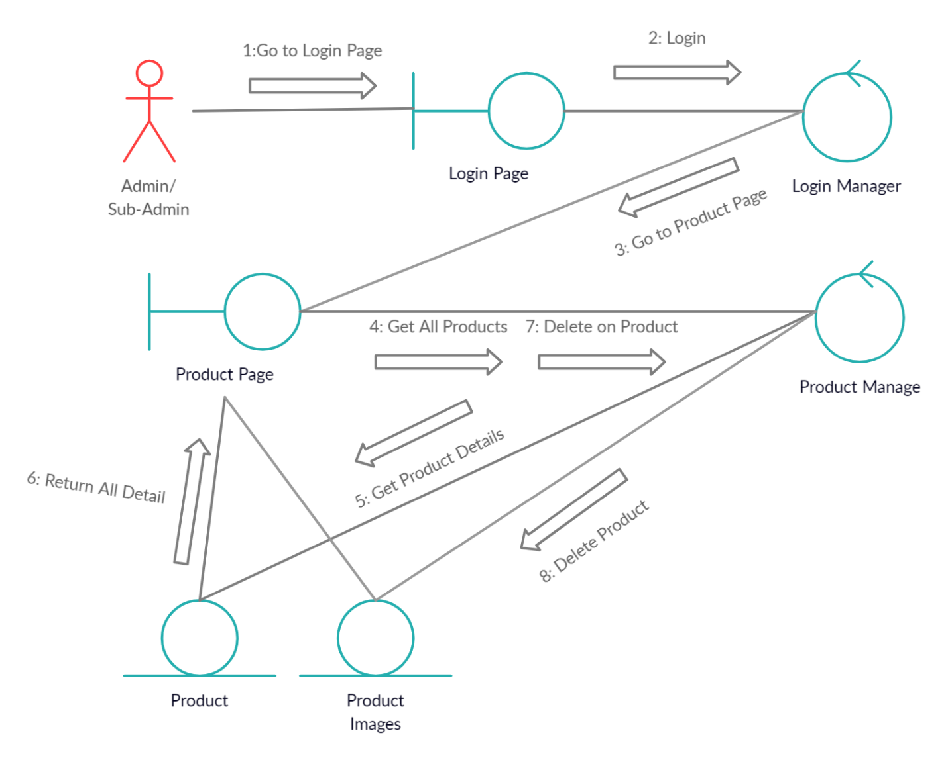

1. **Change Order Status**

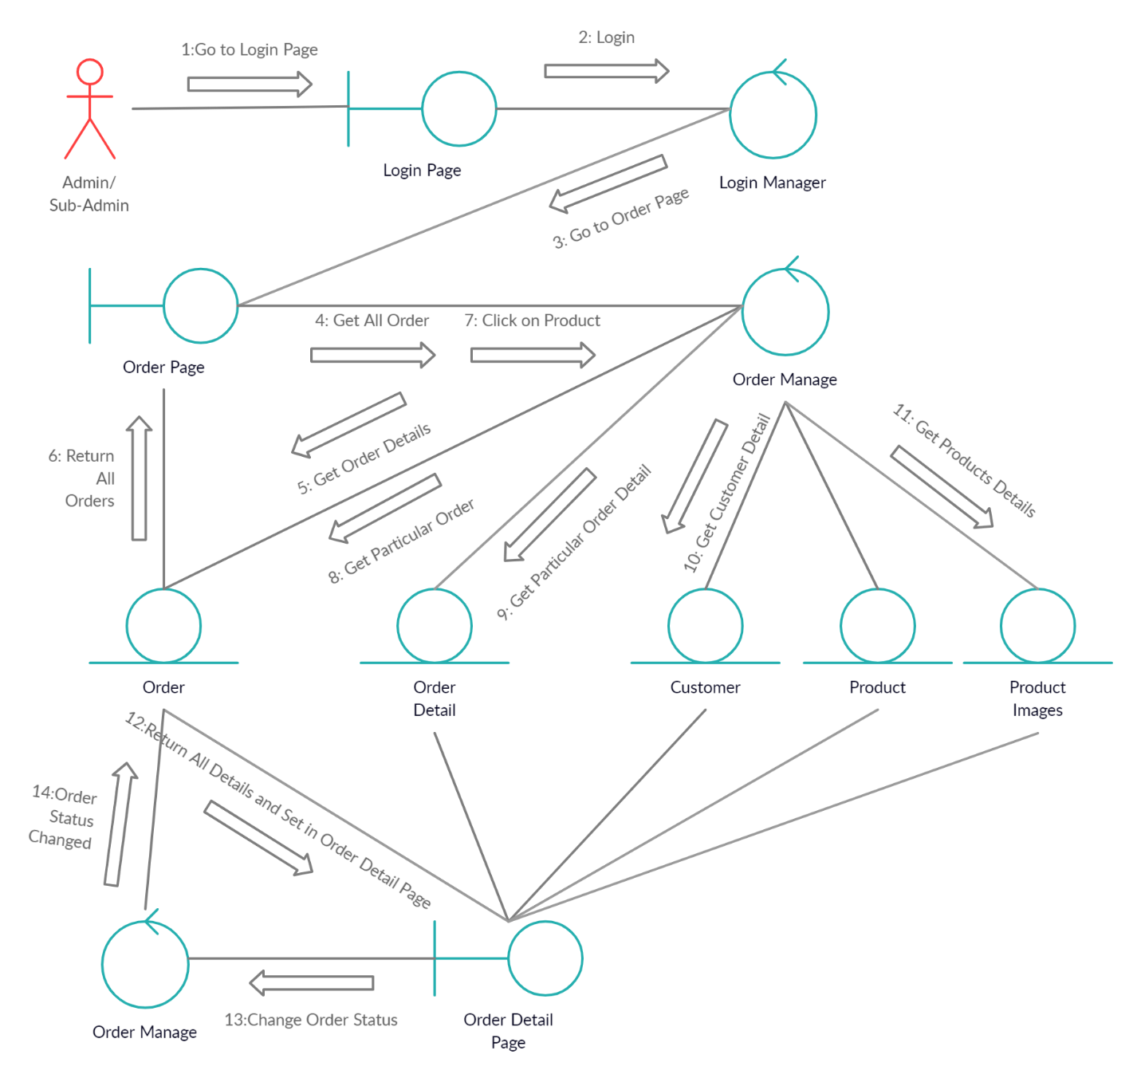

1. **Add to Cart and Check Out**

